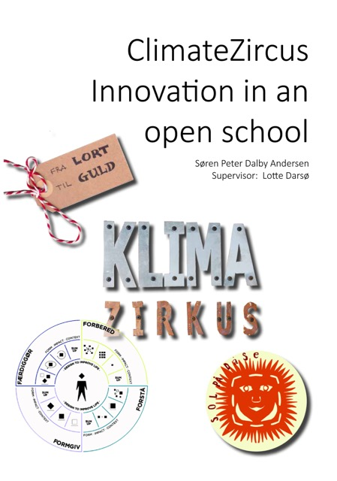

Executive summary
Purpose – The practical purpose of this study is to gain a deeper understanding of how the agenda “The Open School” and innovation processes affect the students in the Danish municipal primary and lower secondary school. Through a case study, I will analyse the local innovation project ClimateZircus which provides the input and empirical data for the content related to the above.

Method – The argument is driven by conceptual analysis and theoretical synthesis based on theory and research on innovation competences, interest, motivation and learning.

Findings – The proposed theoretical framework portrays innovation competences as five competences: 1) action, 2) creativity, 3) collaboration, 4) navigation and 5) communication competence. My analysis suggests that these five competences are a useful lens for describing and analysing a primary and lower secondary school student’s innovative competence. Additionally, Lotte Darsø’s four innovation roles 1) the gardner, 2) the jester, 3) the conceptualizer, and 4) the challenger (Darsø, 2011) can be used as a constructive description and guideline as to how an “innovative student” interacts with others.
It seems that the ClimateZircus puts forward constructive conditions for creativity and meaningful urgency. Further, the collaboration with a local business and the use of innovative processes have a positive effect on the majority of the students' interest and motivation.

Regarding what type of learning ClimateZircus generates/stimulates, the teachers express that education through innovation is a beneficial focus rather than education for innovation. They focus on the fact that the students need to learn to master and navigate in the phases of the innovation processes. Additionally, the students' encounter with the complexity of the “real world” forces them to work together and create solutions 'on the fly'.

Originality/value – This Master Thesis adds to previous research through its focus on how innovative competences are described, analysed, and developed in the context of the Danish municipal primary and lower secondary school. It thus establishes connections between innovation research and research on learning.

Keywords – Innovation, Learning Environment, Interest, Open School, Motivation, Graphic Facilitation, Innovation Competences.

Acknowledgements.
Writing a thesis that sums up a transformative learning journey over a few years is not easy, but I have had good support from people around me.
Foremost, I would especially like to thank my wife, Maria Wagner Andersen, for her patience during my journey, her critical reads and energy to debate findings with me at any hour of the day. I also have to thank Hans Henrik Petersen from www.paraphrase.dk for his help in getting my thoughts readable on paper.

It is important to give credit to the municipality of Hvidovre who has had the courage to engage in a co-creation between schools and the local companies years before “The Open School” agenda arrived. The leaders of the municipal primary and lower secondary school of Langhøjskolen and at the municipality have provided me with a space that allowed me to grow as a person and professional individual - I will be forever grateful for that.

Furthermore, it is important to give credit to all the dedicated people from the team behind the project “From Shit to Gold” which includes the Dansborg Skolen in Hvidovre, the teachers, the students, Anne-Marie Avire Rawlins (REnescience Denmark), Gitte Højgård (DONG Energy), Bo Steen Mikkelsen (ARC), Marie Conradi (LabCopenhagen), Per Velk (Dansk Standard), Anders Sørensen (GAIA Solar), Kristian Mandrup Pedersen (BIOFOS), Peter Rod (UCC) and the municipality of Hvidovre’s innovation consultant Elizabeth Gray. You have given me the chance to follow and document your inspiring work. I would not have been able to write this Master thesis without your openness.

Special thanks goes out to Peter Claudell, my partner in ClimateZircus, who has the most inspiring mind set a business owner and colleague can have - it is a privilege to dream up new projects with you.

Thanks to my supervisor Lotte Darsø for constructive and creative feedback sessions; constantly pushing my levels of abstraction and capacity to cope with complex theory. Additionally, conversation with my former supervisor Søren Cryess Bagger from UCC has inspired me to unfold and investigate of the didactics related to innovation in the content of the primary and lower secondary school.

Finally, I would like to thank the people in LAICS for a truly inspiring and life-changing educational experience.
Søren Peter Dalby Andersen,
Spring 2016

Index
Executive summary 2
Acknowledgements. 3
Introduction 7
My problem statement: 8
Scope 8
A brief overview of the chapters 10
Method 12
Positioning the case. 12
Introduction of theory 13
Innovation, competences and 21st century skills 14
Learning environment, learning and interest 14
Generating and processing the empirical data. 15
Research structure 17
Ethics 18
Interview students and teachers 18
Logbook 19
LRS and WRS 20
Questionnaires 20
Triangulations 21
Theory examination 23
Innovation 23
What is an innovation process? 23
Creativity vs. Innovation 24
What are innovative competences and 21st century skills? 25
Interest and motivation 27
A historical outline 27
Situational and individual interest 28
Terasa Amabile and motivation 30
Time-Pressure/Creativity Matrix 31
Learning 32
Learning as two metaphors 32
Education for innovation vs. education through innovation 34
What is a learning environment? 34
Graphic facilitation – the unforeseen factor 36
Sum up - theory 37
Analysis 39
The innovative competences 39
The Diamond of innovation 39
The Upper Secondary School Thought over Again 41
Sum up – innovative competences 47
Interest and motivations 47
Sum Up – interest and motivation 50
The learning environment 51
LRS – Learning Rating Scale 52
WRS – Wellness Rating Scale 55
Sum up – The learning environment 60
The project wall 60
How to implement innovation. 63
Municipalities 63
Primary and lower secondary school leaders 64
Teachers 66
Conclusion 69
Perspectives 73
References 75
Webapges: 77
Appendix 79

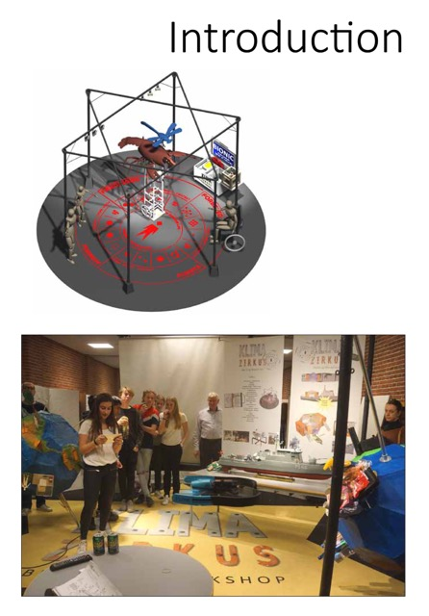

Introduction
Among politicians there is a growing focus on nurturing students’ employability and it is argued that education has contributed to the improvement of our society and economic growth (Cerych & Furth, 2011, in Nielsen, Tolstrup Holmegaard, 2014). Furthermore, having workers who have innovative competences is seen as key to continued economic welfare (EU-Commission, 2010) and politicians agree that students should be given competences which meet the demands of the modern job market (European-Commission, 2011).
In order to secure that the next generation has a solid amount of innovation competency, the educational systems require new aspects that boost the students' innovative competences and 21st century skills (OECD, 2010). The National innovative capacity is the ability of a country to produce and commercialise a flow of innovative technology in the long term (Furman et al., 2002, p. 899–933). The school system can contribute to the national innovation capacity by ensuring that its students are given a high level of knowledge and innovative competences.
Within recent years, different research fields have supported the use of co-creation within groups who seek innovation (Cross, Parker, 2004). I believe that this trend has and will slowly find its way to the municipalities and our school system. In 2013, the Danish government started a reformation of the Danish school system, called “The Open School”. The agenda encourages the schools to collaborate and co-create with local businesses and cultural organizations (Danish Government, 2013).
To understand the national context of this master thesis, it is important to have three specific governmental agendas in mind.
- In 2012, the Danish government produced an innovation strategy called “Denmark - land of the solutions”.
The vision of the innovation strategy is that Denmark should be a country where innovative solutions to major social challenges are translated into growth and jobs.
The strategy focuses on three main areas:
- Social challenges to drive innovation.
- That more knowledge must be translated into value.
- Education - to increase the innovation competences. (Government Agreement, 2012)
- School reform and “The Open School”
Schools must be more open to the surrounding community. This will be accomplished by integrating local sports clubs, cultural centres and other associations into the schooldays by committing municipalities to such cooperation (The Ministry of Education, 2014)
- New simplified joint goals
The Danish school system has introduced new joint goals in all subjects. The joint goals are the teacher’s tool and guide to meet the specific subject’s curriculum. Innovation and entrepreneurship are, as a new addition, also getting joint goals, but it will be a “non-scheduled” subject. This means that it will be a requirement that all subjects are part of the joint task: to increase the student’s innovation competences (www.emu.dk, New simplified joint goals).
ClimateZircus is a local project which works by means of innovation and co-creation between the municipality, municipal primary and lower secondary schools and local businesses. The project refers to the three governmental agendas by: 1) encouraging schools and local business to co-create, 2) using social challenges to drive innovation, and 3) educating the school children in innovation processes - to increase their innovation competences.

I find it important and interesting to investigate how these agendas influence the Danish school system.

My problem statement:
In which way does the innovation project ClimateZircus increase the students’ innovation competences. What type of learning is generated? And how does an innovation process affect the students' learning environment?

Scope
I have several years of experience with innovation projects revolving around students, dealing with authentic issues and co-creating with a local business. My experience tells me, when I compare ClimateZircus methods with the traditional school methods, that the students learn different things and in a different way. I am curious about why the methods used in ClimateZircus change the students’ school day and I will use this master thesis to examine this.

According to King, Keohane and Verba (1994:18, in Darsø, 2001: 208), a good research sub-question satisfies two criteria: “it should deal with a significant real-world topic and be designed to contribute, directly or indirectly, to a specific scholarly literature”.
The first half of my problem statement deals with a “real-world” topic by addressing the following research sub-questions:
- What skills are involved in innovation competences?
- How might ClimateZircus affect the students’ interest and motivation?
The second half of the problem statement contributes to a scholarly literature by addressing the following research sub-questions:
- How might ClimateZircus and innovation processes affect the students’ learning environment?
- What is the link between innovation processes and learning?
In addition to the “real-world topic” factors and contribution to scholarly literature King, Keohane and Verba state that an important objective of an eligible problem statement is the aspect of practical usefulness (King, Keohane and Verba, 1994, in Darsø, 2001:209). In conjunctions with a practical usefulness, I wish to develop a set of recommendations and advice to organisations and schools who wish to engage in an open school project that implicates innovation.

I will answer the problem statement by building on theory based on the works by Lotte Darsø, Teresa Amabile, John Dewey and use the co-creation project “ClimateZircus” as a case study, and compare my findings with existing studies such as “Isi 2015” (Sølberg, 2015) and “The Upper Secondary School Thought Over Again” (Nielsen, 2015).

I will, in the chapter “How to implement innovation”, sum up and discuss my findings in a set of recommendations. The recommendations will target others who wish to enter the world of “innovation in the open school”.

The recommendations will focus on the following three levels:
- Municipalities
- Schools leaders
- Teachers

A brief overview of the chapters
Following the introduction and problem statement, the method of the study is unfolded. The method covers my positioning, introduces the main theories as well as my considerations regarding the research structure, empirical data selection, and how I transcribed the data. This leads up to a chapter covering a theoretical framework that examines and connects theory related to innovation, competences, motivation, interest and learning.

This is followed by an analysis which, on the basis of my theoretical framework and empirical data, examines the students’ development of innovative competences, interest, motivation
and how an innovation process affects the students’ learning environment.
This leads to a set of recommendations concerning how municipalities, primary and lower secondary school leaders and teachers can implement innovation. The recommendations are based on a comparison of and reflection on the findings from my analysis.

The study is summed up in a conclusion which ties the theoretical framework and the analysis’ findings to my problem statement together.

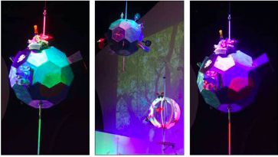
Final student products

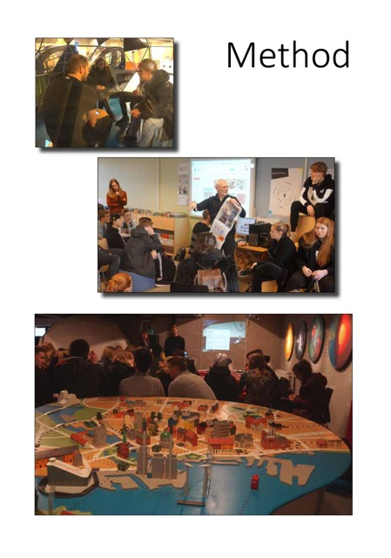

Method

Positioning the case.
Prior to positioning my role in the case study, it is important to introduce the case and argue that a case study is a constructive method to examine my problem statement.

Yin argues that it is recommendable to carry out a case study when a phenomenon is complex, contemporary and not easily distinguishable from its context (Yin, 1994, in Lotte Darsø, LAICS seminar 1, module 4). By examining ClimateZircus, I seek to understand how innovation and an open school project might affect different aspects of the Danish municipal primary and lower secondary school.

As mentioned earlier, ClimateZircus is a project that wishes to promote sustainability and innovation to students by engaging in co-creation with students and local businesses. It builds on the experiences from the project called “Students of Ellehammer” which is a local project that originates from the national project called “Science Municipalities”. Science Municipalities was carried out in 2008-11 and its main purpose was to help schools to engage in collaboration with local businesses and informal learning environments (Jensen, 2011).
In this case, ClimateZircus is engaged in the project “From Shit to Gold”. A co-creating project between, UNIVERSE (a theme park), BIOFOS (a wastewater facility), ARC (a waste-to-energy power plant), 60 students from 9th form from the Dansborg Skolen and their four teachers. All pictures included in this report are “shot” by students during the work process.

To research a co-creation between students and a local business is a complex matter. Furthermore, when trying to understand how the phenomenon “The Open School” and innovation affect the learning environment, it is not easily distinguishable from the “normal school day”.

With Yin and the structure of ClimateZircus in mind, it is my aim to base my master thesis on an eligible real-life case study. Since the study aims at providing insight into the open school agenda and refine the theory concerning innovation, I will categorise the case as an instrumental case (Stake, 1994).

A case study of ClimateZircus enables me to concentrate my attention on both how “The Open School” and how an implementation of an innovation process affect the students and their teachers.

I will, in the following, examine my role and contemplate the possibility that I might be a double insider. A double insider means being an insider in relation to the research matter and in relation to one’s interviewees (Adriansen and Madsen, 2009). It is, in my case, the following three interfaces that are the important factors:

1) The project “Students of Ellehammer”
In 2008, Hvidovre local political council decided to participate in the Science Municipalities project and I was assigned to develop, implement and handle the daily operations of the project – which I did in the period 2010 - 2015. I was not given specific commissioning powers, but it was expected that I found a constructive method and structure for the collaboration between schools and local businesses in Hvidovre. To meet this challenge, I started the project “Students of Ellehammer”.

2)The project “ClimateZircus”
As mentioned earlier, ClimateZircus is a project that wishes to promote sustainability and innovation to students by engaging in co-creation with schools and local businesses. I am not employed in the project, but I founded ClimateZircus with the architect Peter Cluadell, who works full-time with the project.
3) I am a trained teacher and have worked as such for ten years.
It is, with point 1 and 2 in mind, clear that I have an attachment to the organizations prior to my study of the case. I assess that my student and teacher interviewees, since they know that I am a trained teacher, will considered me an insider.

With the above mention factors in mind, it is fair to conclude that I am a double insider, which has both advantages and disadvantages. By having a connection to the case and interviewees prior to the study, I have an advantage of extensive knowledge of the case, the school systems social norms, culture and language.

The disadvantages is a presumed shared knowledge and that (even though I try not to) I in a sense have certain expectations about the outcome of the case study (Adriansen and Madsen, 2009).

Introduction of theory
The coming paragraphs will give a brief introduction to the theory I will use in the interview. The introduction will focus on why the theory is relevant and how it will contribute to getting a better understanding of or answering my problem statement. I will go in to depth with key terms and theory in the chapter called “theory examination”.

Innovation, competences and 21st century skills
Lotte Darsø’s understanding of innovation competences, the learnings from the project “The Upper Secondary School Thought over Again” (Nielsen, 2014), learnings from the project ISI 2015 (Sølberg, 2015), and the theory dealing with 21st century skills will be the theoretical frame that I will use to answer research sub-question number 1:
- What skills are involved in innovation competences?
I will use John Dewey, Lev Vygotsky and Morten Rask Petersen to give me a perspective that enables me to answer research sub-question number 2:
- How might ClimateZircus and innovation processes affect the students’ interest and motivation in the school?
Amabile’s “Time pressure/creativity matrix” (TPCM) (Amabile Hadley, K. & Kramer, S.J., 2002) will be used to analyse and assess how an innovation process and ClimateZircus affect the students' motivation and creativity.

Learning environment, learning and interest
To understand the term learning environment, it is relevant to introduce and recognise the correlation between the terms interest and learning.

Consequently, I need to understand the two terms separately. To get an understanding of why interest is relevant in the educational research, I will – based upon John Dewey’s research (Dewey, 2013) – draw an historical outline of the research related to the term. I will use Suzanne Hidi’s approach to define my understanding of the term interest, and to uncover how a student’s interest occurs/develops I will draw upon Vygotskys theory called the "zone of proximal development" (Jerlang, 2006) as well as the terms situational and individual interest (Dohn, 2006).

I will use Lotte Darsø’s Diamond of innovation as the analytical tool that will enable me to shed light on how the students' interact with the companies.

The Diamond of innovation does also allow me to draw upon Heron and Reason’s four ways of knowing (Darsø, 2011).

This frame combined with LRS and WRS tests allow me to shed light on research sub-question number 3:
- How might ClimateZircus and innovation processes affect the students’ learning environment/space?
To give me a theoretical frame and understanding of the term learning, I will use Knud Illerris and Anna Sfard analysis of learning in the perspective of two metaphors (Sfard, 1998).
This frame will help me to answer research sub-question number 4:
- What is the link between innovation processes and learning?
The students and teachers I followed used the innovation model “Design to Improve Life Compass” (The Compass) as their innovation process. It is a normative model based on an iterative process. I emphatise greatly with the fact that Design to Improve Life education is open source material and I have successfully used the material in my own teaching (www.designtoimprovelifeeducation.dk).

Generating and processing the empirical data.
To build a framework for generating my empirical data, I have used Ken Wilber’s All Quadrants, All Lines and Levels model (AQAL – figure 1). Ken Wilber argues that change occurs in the context of the whole system and by addressing all four key perspectives of the AQAL model it is possible to create a frame to understand the change (Wilber,2000).

The AQAL model provides me with a framework that I can use to understand how ClimateZircus affects both the:
- Individuals involved - the students and teachers.
- The environment – the school and the local school system.
The intentional quadrant (upper left quadrant) deals with “what I experience” and with the thoughts, emotions and feelings of the individual (ibid.). I have conducted focus interviews with teachers and students and asked the students to write a logbook. This will generate data that cover the aspects of the intentional quadrant.
The behavioural quadrant (upper right quadrant) relates to “what I do” and review the individual behaviours and objective aspects of reality (ibid).
I have carried out Learning Rating Scale (LRS) and Wellness Rating Scales (WRS) examinations to cover this quadrant.
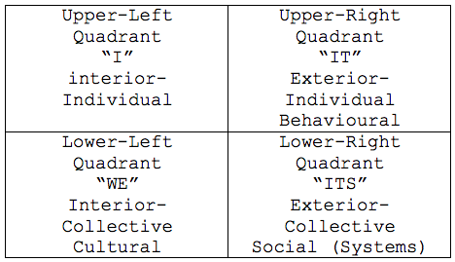
Figure 1 - (Wilber, 2000)
The Cultural quadrant (lower left quadrant) deals with “what we experience” and relates to the way things are unconsciously done, the culture (ibid).
To generate empirical data that give me insight into the cultural quadrant, I have conducted interviews with students, teachers and a learning consultant.
The System quadrant (lower right quadrant) relates to “what we do” and the organisational systems, rules, conscious ways of operating (Ibid.).
To generate data that give me insight into the system quadrant, I have conducted digital questionnaires. The above has accounted for and explain the intentions behind the involvement of the elements in my research structure.
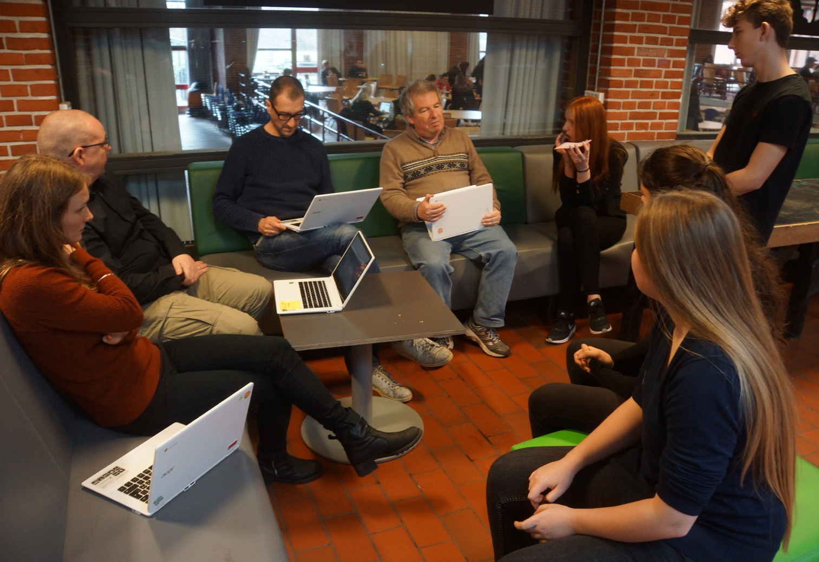
Students are receiving feedback

Research structure

Based on the AQAL model, I have arrived at the following research structure:

 | Before | Under | End | Comment
Students interview | X (day 1)  3 groups of 4 students. 10 min. | X (day 5)  3 groups of 4 students. 10 min. |  | Focus group interview
Teacher interview | X (day 1)  Focus group interview. 25 min | X (day 5)  One teacher  20 min.
Local business interview |  | X (day 5)  20 min |  | 2 interviews  Marie Conradi and Kristian Mandrup
Consultant  interview | X Day (1)  Peter Rod 16 min | X (day 5)  Elizabeth Gray 12 min |  | 2 interviews
LRS | X (day 1) | X (day 5) | X (day 10) | 40 students  2 9th form classes
WRS | X (day 1) | X (day 5) | X (day 10) | 40 students  2 9th form classes
Logbook (every day) | X | X | X | 60 students  3 9th form classes
Questionnaires students |  | X day(6) | X (day 10) | 60 students  3 9th form classes
Questionnaires  teachers |  |  | X (day 10)

Ethics
When generating data, through qualitative and quantitative methods, ethics are always important. I handled this aspect by guaranteeing the interviewees that all names referring to data would be anonymised. Some of the adults have accepted that I publish their names.

The data generated by the WRS/LRS test and questionnaire are automatically anonymised. I am not able to delete or anonymise the students’ personal logbooks since they are digital and owned by the students. This fact has been brought to the students’ attention and they can personally delete the logbook if they wish.

The interviews, questionnaires, LRS/WRS and logbooks were carried out in Danish and all quotes referring to focus group interviews, as well as any other data, have been translated by me.

Interview students and teachers
I have conducted six focus group interviews with an attendance of four students in each interview. The interviews lasted 10 min., and three were conducted the first day of the project and three on day 5. The teacher interviews were conducted on day one and five.

The intention with the interviews is to get an understanding of the Cultural quadrant (Wilber, 2000) and to get an understanding of what the teachers and students expected of as well as how they experienced the innovation process.

The intention with the interview was also to maybe stumble upon a topic or aspect I did not expect to be relevant. With that in mind, I decided to conduct the interviews using a General interview guide approach. This allows me to generate data from the same areas, but still open up for a degree of freedom and adaptability in the process of generating the data (Kvale, 1996).

All interviews were conducted as focus group interviews. This has several strengths as the focus group interview allows me to:

- Generate rich qualitative data which can be generated with reasonable speed.

- Gain access to the range of complexity of attitudes which can came to light in a dialog. Participants are encouraged to interact with each other.

- Take gestures, facial expressions and other forms of non-verbal communication into account.

- Explore the unanticipated aspects of the problem under study.
(Rana Muhammad Dilshad, Muhammad Ijaz Latif, 2013)
The weakness associated with focus groups is:
“A few vocal participants may dominate other members in the course of group discussion. Because of the nature of group conversation, some participants may conform to the responses of other participants, even though they may not agree” (ibid, pp 197).

I will use meaning condensation as transcription method. The method results in a synopsis of the meaning expressed by the interviewees. Long statements are compressed into statements in which the main sense of what is being said is restated in a few words (Kvale, 1996).

The process of transcribing the interviews consists of three steps.
- I listen to the full interview and write down the main topics.
- I listen to the full interview and pay attention to a certain topic
- I listen to the full interview and pay attention to another certain topic.
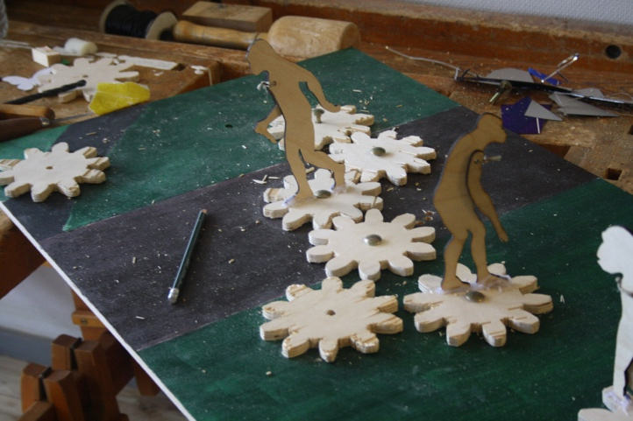

An example of this is the transcription of a student focus group interview on day one.
- I listen to the full interview and write down the main topics.
  - Expectations towards the innovation process
  - Expectations towards working with a real-life challenge and business

- I paid attention to the topic expectations towards the innovation process.

- I paid attention to expectations towards
working with a real-life challenge and business
The interviews with the local business and the consultant will primarily be used, via quotes, to consolidate the learnings I generate through the other data methods.

Logbook
By asking the students to write a logbook, I intent to get access to the students’ thoughts - the intentional quadrant (Wilber, 2000). Sixty students have, in groups of four, been keeping a daily logbook. I will read the fifteen logbooks, but I will not transcribe them. They will primarily be used, via quotes, to consolidate the learnings I generate through the other data methods. This prioritisation is made due to the limited time and the vast amount of data. I

LRS and WRS
Learning Rating Scale (LRS) and Wellness Rating Scale (WRS) are qualitative tools that allow me to measure how the students experience the learning environment (Nissen, 2012). The tests will allow me to generate data which help me to answer the part of my problem statement that deals with: How might ClimateZircus and innovation processes affect the students learning environment?

Boxplots and web charts (figure 2) will be used as the main tools in my quantitative description of the data generated with LRS and WRS. A boxplot is a tool to graphically depicting my data through quartiles, and the web chart is a tool that allows me depict all the variables in the LRS and WRS data.

Furthermore, the boxplot allows me to analyse the LRS and WRS data on a general level and the web charts allow me to get a closer look on every variable measured in LRS and WRS tests. The students answered the LRS and WRS tests via smartphones.

Questionnaires
With the intention of gaining access and insight into the system quadrant (Wilbur, 2000), I have conducted the following three questionnaires:

- Students (day 6) with focus on how it makes sense to introduce the students to innovation processes.
- Students (day 10) with focus on how ClimateZircus and the innovation processes affected the students work.
- Teachers (day 10) with focus on how The Compass affected the students and what competences the process “gave” the students.

I used a digital survey platform called “Surveymonkey” and both students and teachers have answered the surveys by the use of a phone, tablet or computer. The use of questionnaires is a quantitative method of data generation and it allows me reach all the students involved in the project. I will compare the findings from the focus group interviews with the questionnaires which gives my study validity.

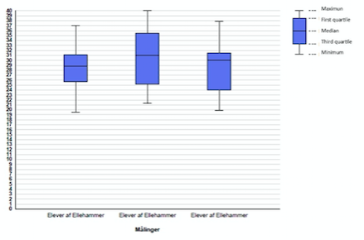
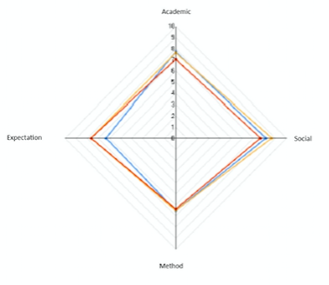
Figure 2 – Boxplot and web chart example

Triangulations
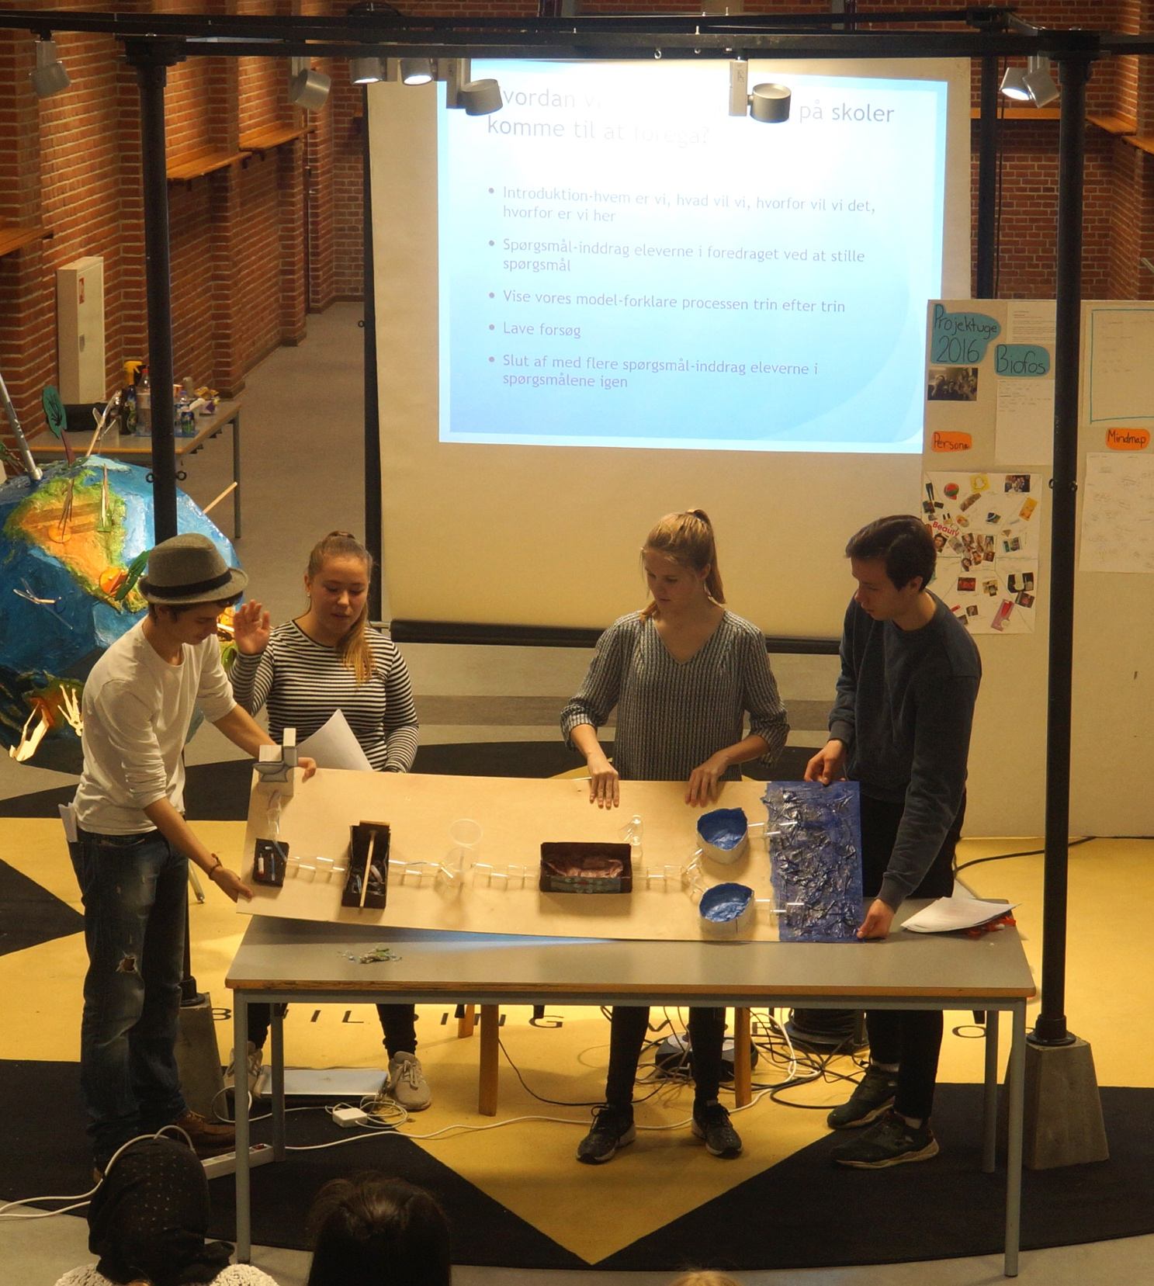
To illuminate my findings and learnings, I use both qualitative and qualitative research methods.
Students are presenting their solution.
The mixing of data types, known as data triangulation, is thought to give validity and reliability to the researcher’s study (Kvale, 1996).

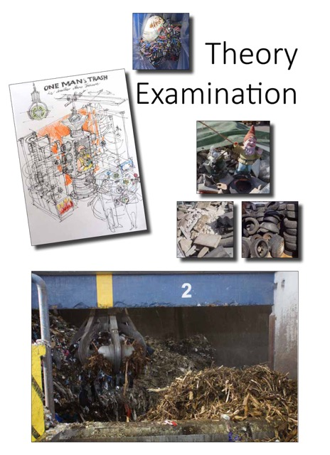

Theory examination
In order to create a theoretical framework for the study, the following section will explore existing literature and establish core concept definitions of the main terms. The central term of this master thesis is innovation, and the theory examination will focus on the connection between interest, motivation and learning.

Innovation
The role of education is to prepare the students for the demands of modern society, skill development and enable the students to participate, demonstrate mutual responsibility and understand their rights and duties in a free and democratic society (The Danish Ministry of Education, 2010). From a governance perspective, we have decided that our school system should boost the students’ creativity and their innovative competences (government agreement, 2012). These two statements lead me to think:

What is, in an educational context, an innovation competence? and what is the distinction and relation between creativity and innovation?
Prior to examining the terms innovation competence and creativity, I find it important to describe the context in which the terms unfold. This leads to the question: What is an innovation process?

What is an innovation process?
Innovation can be seen as the outcome of the invention, development and implementation of a new idea (Garud, Tuertscher, & Van de Ven, 2013, p. 774). The outcome of the process can be categorised as incremental or radical (Darsø, 2001, p. 28). Incremental innovations are smaller improvements of products, processes or methods.
A radical innovation has a major effect on both consumers’ behaviour and on the marked in which the product, process or methods compete (Markides & Geroski, 2005). An innovation process can be described as “a sequence of events that unfold as ideas emerge, are developed, and are implemented within firms, across multi-party networks and within communities” (Garud et al., 2013, p. 774).

ClimateZircus uses “The Compass” to guide the students through the innovation process. It has a framework that is developed through cooperation between teachers, didactic experts, facilitation experts and designers from Denmark and Sweden. 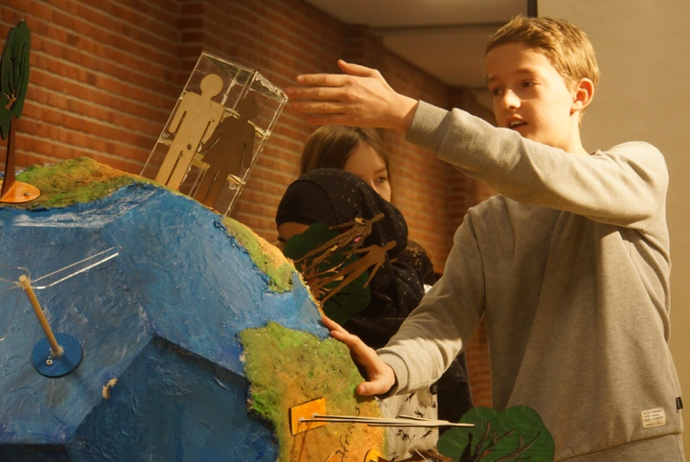
Its methods derive from knowledge about global challenges (e.g. food waste, climate change and over-population), design processes and a vast catalogue of design solutions. The Compass is supported by assignments and more than 1,000 teachers and 10,000 kids have already tested the methods.

The Compass has a process that is based on the four phases - the four P’s.

1. Prepare: The objective of the prepare phase is to get the students’ to plan and understand the process ahead of them.

2. Perceive: The objective of the perceive phase is for students to identify what they know and what they want and need to know about their challenge.

3. Prototype: The objective of the prototype phase is to get (many) ideas about how the product or solution will actually be shaped.

4. Produce: The objective of the produce phase is to create a product or solution by connecting the knowledge I have gained in the prepare, perceive and prototype phase. (www.designtoimprovelife.dk)
Every phase builds on different assignments that lead the students through a process of 1) diverging, 2) converging and 3) sparing with others.

Creativity vs. Innovation
Amabile introduces creativity as: “how people approach problems and solutions — their capacity to put existing ideas together in new combinations. The skill itself depends quite a bit on personality as well as on how a person thinks and works” (Amabile, 1998).

In the literature concerning creativity, innovation is well-know, and as McLean points out, the distinction between innovation and creativity is very important. Creativity is a phenomenon that is initiated and exhibited at the individual level with a focus on expertise and personality. Innovation operates much more at the group and organisational levels. The focus is on
interrelationships, interactions and dynamics in the group/business (McLean L D, 2005).

Mclean and Amabile provide an understanding of the distinction and relation between creativity and innovation. Yet, they reveal no insights into which educational criteria should be used for assessing a student’s innovation competence. I will, in the following, seek an understanding of what innovation competences are.

What are innovative competences and 21st century skills?
Prior to commencing on a better understanding of innovation competences, I need to define a distinction between a competence and a skill.
Rychen and Salganik argue the following:

“A competence is more than just knowledge or skills. It involves the ability to meet complex demands, by drawing on and mobilisation psychosocial resources (including skills and attitudes) in a particular context (Rychen & Salganik, 2003, in Ananiadou, K. & M. Claro, 2009, p. 8).

The project “The Upper Secondary School Thought Over Again” (Nielsen, 2015) has studied how teachers in the upper secondary school talk about innovation competences. The research points to the notion that, when students deal with innovation processes revolving around authentic issues, a student’s innovation competences can be assessed by measuring these five sub-competences:

Action: The extent to which the student can implement her ideas; assess and take risks; and collect information from other sources than the classroom.

Creativity: The extent to which the student can find, not just idiosyncratic ideas/solutions, but a range of different ideas/solutions, and then sort, prioritise, and extend selected ideas/solutions.

Collaboration: The extent to which the student can take responsibility for a group finishing a task, and be inclusive and versatile when it comes to group work – e.g. by demonstrating that she can utilise how the skills and knowledge of others complement her own.

Navigation: The extent to which the student can use her disciplinary background to decode a task or an issue; assess which information is critical for solving a task/addressing an issue; and take ownership of and plan complex work process.

Communication: The extent to which the student can analyse how to communicate with a specific target group; can master different communication techniques and methods; and can communicate in an engaging and convincing manner (Nielsen, Tolstrup Holmegaard, 2015, p. 4).

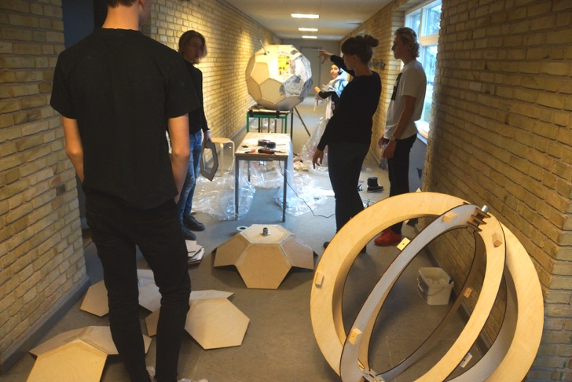
Jan Alexis’s study offers a thorough peek into how educators from the Danish upper secondary school think about innovation competences, but do the learnings of the study transfer to the primary and lower secondary school? We do not have a just as thorough research on what is viewed as innovative competences in the Danish municipal primary and lower secondary school.
However, the final evaluation report of the ISI project reveals relevant insights. The study shows that students who use innovation to solve an authentic issue develop skills within the following:
- Communication
- Independence
- Self-esteem
- Collaboration
- Creativity
- Better at using a process to solve a problem
- Critical thinking
(Sølberg, J., et al., 2015, p. 208 - 220)
All of the above are skills which relate to 21st century skills (OECD, 2010), and they do all in some way connect to the five innovative competences that Jan Alexis Nielsen described. Although, this study concerns students from the upper secondary school, the connection between the two studies allows me to assume that Jan Alexis’ description of an innovative competence can be transferred to a Danish municipal primary and lower secondary school context.

Jan Alexis’ and Jan Sølvberg’s understanding of innovation competences relates to Lotte Darsø’s definition: “Innovation competency is the ability to create innovation by navigating effectively together with others in complex contexts” (Darsø, 2014). Furthermore, Lotte Darsø introduces, through the “Diamond of Innovation”, four innovation roles called the gardener, jester, conceptualizer and challenger (Darsø, 2003). The roles are describes as:

- The innovation gardener works to develop the relational competence in the group. This means being aware of the participants’ well-being, which is connected with each individual person’s motivation and opportunity to contribute.

- The innovation jester helps the group explore what they do not know. This leader is responsible for stimulating the group to ask questions and propose ideas. There are five types of questions that are relevant to work with: the “stupid”, “crazy”, “impossible”, “burning” and “hypothetical” questions.

- The innovation conceptualizer tries to get the participants in the group to describe and illustrate information and knowledge in different ways. This leader is responsible for clarifying concepts and agreements/disagreements in the group.

- The innovation challenger assists the group in building a solid knowledge base. This role’s main task is to challenge all the knowledge and information that emerge as potential contributions to knowledge creation. (Darsø, 2007, p. 7-9)

The Diamond of Innovation allows me to analyse the student’s innovation competences, by focusing on the four innovation roles and how the student interact with the partners involved in ClimateZircus. I will use Lotte Darsø’ four innovation roles and Jan Alexis five innovation competences to assess if ClimateZircus develops and/or increases the student’s innovation competences.

Interest and motivation
The research sub-question: “How might ClimateZircus and innovation processes affect the students’ interest and motivation in the school?” calls for a definition and introduction to the terms interest and motivation.

The term interest has been in focus, as a theoretical research field, since the early pedagogical and didactical thinkers. Comenius, Rousseau and Kant perceived by intuition that interest was connected to the term learning (Petersen, 2012). My understanding of the term relies on the following definition:

”... a unique motivational variable, as well as a psychological state that occurs during interactions between persons and their object of interest, and is characterized by increased attention, concentration and affect” (Hidi, 2006, p. 70).

The following will give a historical outline of how interest is stationed in the educational research and generate a link to Amabile’s work-related research on motivation.

A historical outline
John Dewey was among the first to do educational research concerning the term interest. His research has, to a vast extent, founded the modern understanding of interest. He defines the term as the following:

"Genuine interest is the accompaniment of the identification, through action, of the self with some object or idea, because the necessity of that object or idea for the maintenance of a self-initiated activity.” (Dewey, 1913)

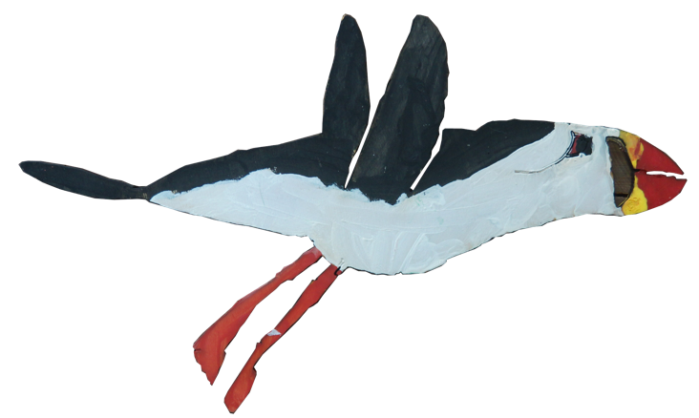
Student drawing
Dewey argues that “genuine interest” derives from an identification of an individual’s interest in an object or idea. This separates the interest from motivation – an individual will always be interested in something and motivated for something. In other words, an individual's interest will always be aimed at an object or idea.

Furthermore, the definition points out that the individual has to identify an interest, which is to be done as an action in relation to the object. Thus, interest is an active action, as it is perceived as an incentive behind an individual’s efforts. Regarding “genuine interest”, it is important that the efforts contain challenges which the individual sees as appropriate. (Petersen, 2012).

The connection between appropriate challenges and interest is also found in Vygotsky’s theory called the "zone of proximal development" (figure 3). This theory points out that a student met with challenges with an adequate level is likely to increase his/her interest. Furthermore, too easy or difficult challenges will decrease the interest (Jerlang, 2006).

Dewey does not give an answer to how an interest develops and it seems as if he assumes that the interest sit on the fence in the student’s consciousness (Petersen, 2012).
But everybody who has taught a little knows that reality is not that simple. This leads me to think - how does an interest evolve? And what factors create, evolve and withhold a student’s interest? The following section will examine the questions above.

Situational and individual interest
The modern field of interest theory distinguishes between two analytical levels of interest.
- Situational interest
- Individual interest
With the term Situational interest, interest is understood as a situation with interaction between a student and an object of interest. The interest is unconscious, generated by an external factor, and is viewed to have a short duration of effect (Dohn, 2007).
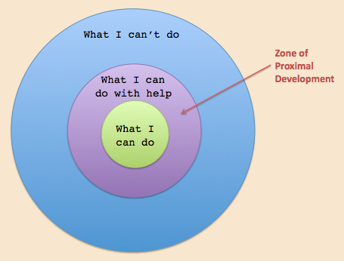
Figure 3, Vygoysky, in Jerlang, 2006
The term Individual interest refers to a conscious interest with long duration. The interest is not inborn, but is based on an individual’s context and experiences. Factors like family, social and cultural background can influence the student’s context and experiences (Dohn, 2007).

I proportion to a student’s interest in an educational situation, it will always be a dynamic mix between the two analytical levels of interest – situational (unconscious) and the more conscious individual interest (figure 4).
Unconscious value Conscious value
Content
Figure 4 - Petersen, 2012
Thus, a student’s interest in an object/subject can evolve from mainly being unconscious to a more conscious interest (Petersen, 2012).

Vygotsky's "zone of proximal development" and the terms situational and individual interest give insights into how ClimaZircus affects a student’s interest, but fail to relate the term interest to innovation. I will, in the following, use Teresa Amabile’s research to understand the link between the terms interest, motivation, creativity and innovation.
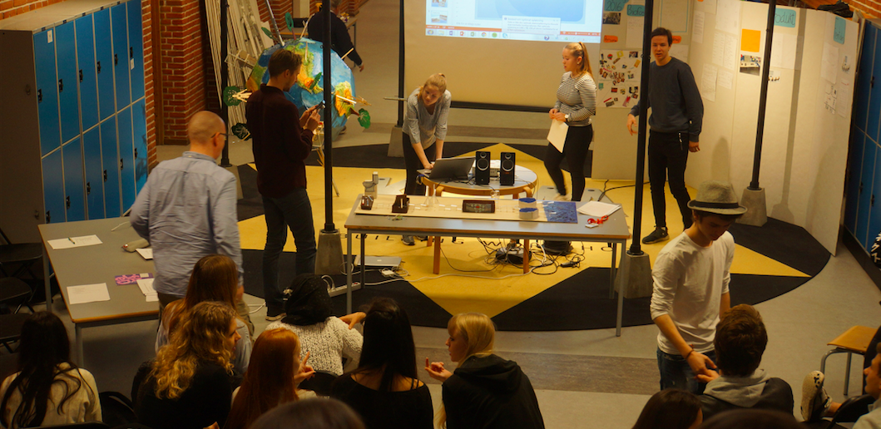
Student presentation.

Terasa Amabile and motivation
Terasa Amabile’s research has demonstrated that not all forms of work-related motivation have the same impact on creativity. In the article “How to Kill Creativity”, she argues that extrinsic and intrinsic motivation are essential for creativity (Amabile, 1998). Amabile reasons that extrinsic motivation comes from outside a person — whether the motivation is a carrot or a stick. In contrast, intrinsic motivation is founded on a person’s internal desire to do something - people are intrinsically motivated by the work itself.

She connects motivation, interest and creativity by introducing the Intrinsic Motivation Principle of Creativity, a principle that argues that students/workers will be most creative when they are motivated primarily by the interest, satisfaction, and challenge of the work itself — not by external pressures (ibid).

A comparison between the educational related terms situational/individual interest and the work-related terms extrinsic/intrinsic motivation reveals a connection between these terms. The terms situational interest and extrinsic motivation both deal with an outside source that triggers an interest or motivation. On the other hand, individual interest and intrinsic motivation deal with a conscious and inner interest or motivation.
Part of my analysis relies on Amabile’s TPCM (Amabile Hadley, K. & Kramer, S.J., 2002) which is originally designed to evaluate adults in a work-related situation. Nonetheless, the above-mentioned connection allows me to use TPCM to analyse how ClimateZircus affects the student’s motivation, interest and creativity.
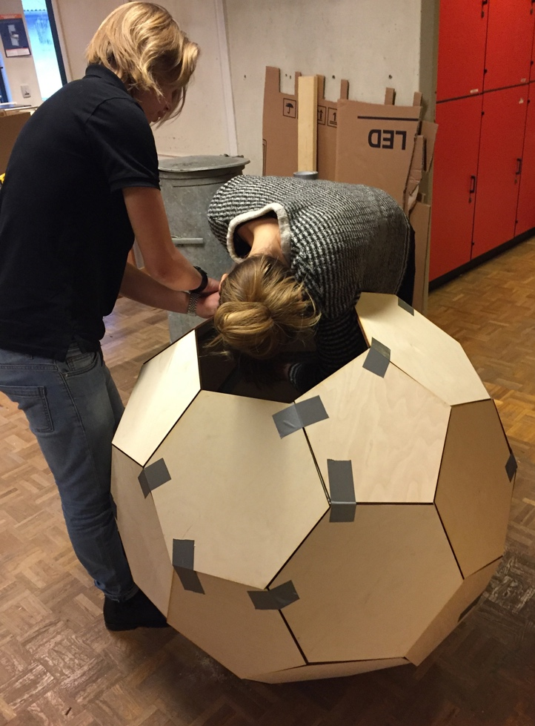

Time-Pressure/Creativity Matrix
The Time-Pressure/Creativity Matrix (figure 5) puts forward that time-pressure affects a person’s creativity.

The impact changes if the environment permits people to focus on their work, communicates a sense of meaningful urgency about the duties at hand, or stimulates or undermines creative thinking.

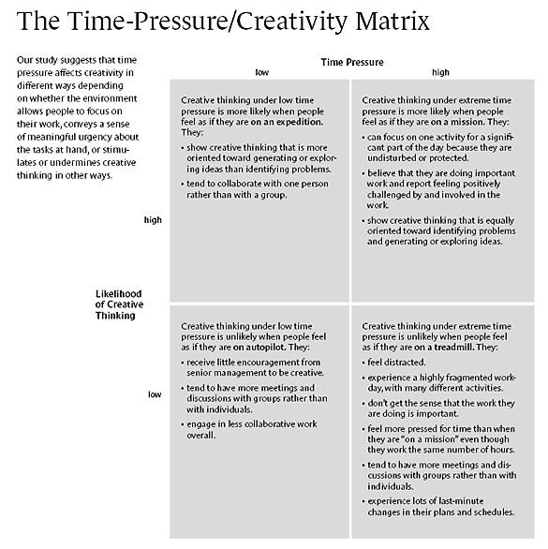
I view TPCM as a normative model I can use to evaluate a change of performance (Darsø, 2014).
Figure 5 - Amabile Hadley, K. & Kramer, S.J., 2002
My intention is to use TPCM as a tool to evaluate if the students experience the methods used in the ClimateZircus as being a mission, treadmill, expedition or as being on autopilot (figure 5) (Amabile Hadley, K. & Kramer, S.J., 2002).

This gives me a perspective that allows me to answer research sub-question number 2: How might ClimateZircus affect the students’ interest and motivation? I will elaborate on this in the analysis chapter called “interest and motivation”.

Learning
It is considered a fact that a minimum of interest is required to learn anything (Todt, 1978). This is an obvious link between the term learning and interest, but how does learning relate to innovation? And how do I measure the learning environment of ClimateZircus? These are questions which I will address in the following, but I will start by defining and elaborating on my understanding of learning as a term.

Learning as two metaphors
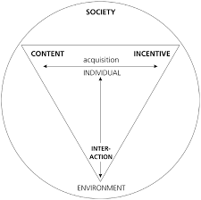
Knud Illeris understands learning as a multifaceted term that relates to all processes which lead to a lasting change in capacity. He views learning as a tension field between content, incentive and environment (Illeris, 2009).
Figure 6 – Illeris, 2009

Figure 6 shows that learning is acquired through an interface between content and incentive.

The incentive is viewed as an expression of the individual’s ability/motivation to immerse in the learning process. The context represents the knowledge, method or term that is being acquired. This tension field plays out in a framework that contains the individual and its interaction with the environment. Illeris considers the interaction essential - this means that it is not the extreme values in themselves, but the interaction between them, that define the learning area (Illeris, 2009). Illeris uses acquisition as a metaphor, but Anna Sfard (Sfard, 1998) argues that learning can also be described with a participation metaphor.

The participation metaphor perceives the term learning as an individual being an active participant in a specific social practice.

The student learns, through his active participation, how he can become a more central person in the context in
which the teacher is to engage him in (Sfard, 1998 – figure 7).

The difference between the two metaphors for learning is fundamentally about how knowledge is perceived.

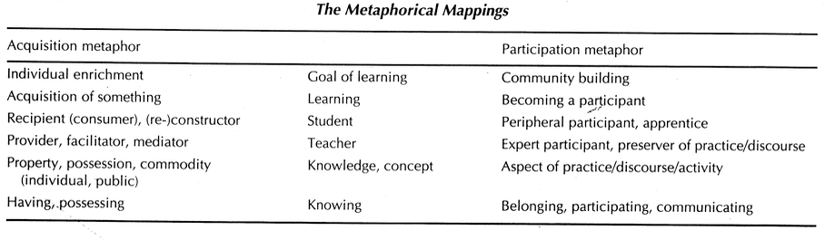
Figure 7 - Sfard, 1998

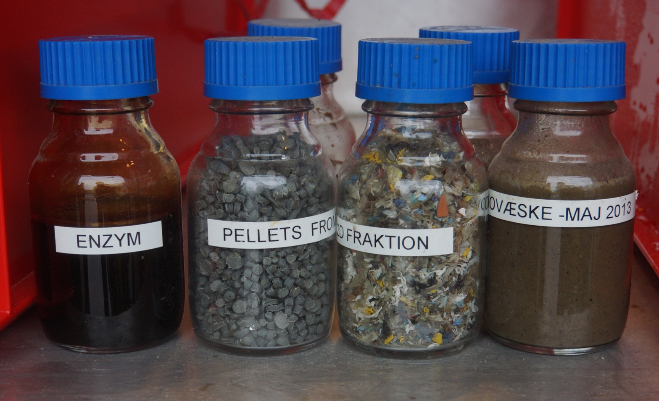
Enzymes and waste products
otte Darsø links innovation to knowledge through Heron and Reason's four types of knowing
(figure 8).

Experiential – to know though direct experience.

Presentational - an intuitive grasp of the significance of patterns as expressed in moving, graphics, musical and verbal art forms.

Propositional – to express the knowledge verbally.

Practical – knowing how to exercise a skill (Darsø, 2011, p. 88).

Anna Sfard, Lotte Darsø, Heron and Reason's theory connects learning and innovation. The following section will elaborate on two views upon how innovation is implemented in education.

Education for innovation vs. education through innovation
In 2014, Kåre Moberg analysed the influence of education for entrepreneurship and education through entrepreneurship on pupils' level of school engagement and entrepreneurial intentions. His research showed that education for entrepreneurship has a positive influence on pupils' entrepreneurial intentions, but a negative influence on their level of school engagement. The opposite is true for education through entrepreneurship (Moberg, 2014). Inspired by Moberg’s findings concerning entrepreneurship, the final report of the Isis project did also examine the distinction between education for and trough innovation.

The Isi project found that the teacher's focus changed from 'educating' towards 'producing' an innovative product (education for innovation) to a focus on the students' understanding and use of an innovation process and his/her tools (education through innovation) (Sølberg, J., Holst Waaddegaard, N., Hansen, F. L., Trolle, O., Elmeskov, D. C., Johannsen, B. F., & Nielsen, J. A., 2015).

This indicates that some of the answer to my research sub-question number 4 (What is the link between innovation processes and learning?) is related to the teacher's focus on education for or through innovation. I am curious to examine if my analysis also shows that the teachers involved in ClimateZircus shift their focus from education for to education through innovation, and I will return to this aspect in the analysis.

What is a learning environment?
In educational terminology, the term learning environment is defined as: “the diverse physical locations, contexts, as cultures in which students learn. Since students may learn in a wide variety of settings, such as outside-of-school locations and outdoor environments, the term is often used as a more accurate or preferred alternative to classroom, which has more limited and traditional connotations—a room with rows of desks and a chalkboard, for example.” (www.edglossary.org).

This correlates with Lotte Darsø who broadens the understanding of the term by stating that a learning environment is a mental, social and physical environment (Darsø, 2011, p. 97).

I will, as mentioned in my method chapter, use the Learning Rating Scale (LRS) and Wellness Rating Scale (WRS) tests to measure how the students experience the learning environment. These tests accept the diversity of a learning environment by including the mental, social and physical aspects in the test.

Figure 9 shows the form used to conduct the LRS and WRS tests.
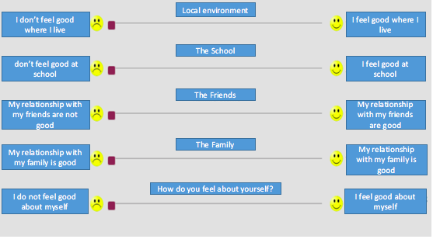
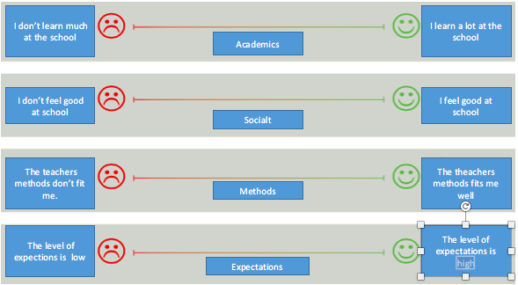
Figure 9 – www.dafolo-tools.dk (translated by me)
The tests will allow me to generate data which will help me to answer the part of my problem statement that deals with: How might ClimateZircus and innovation processes affect the students' learning environment?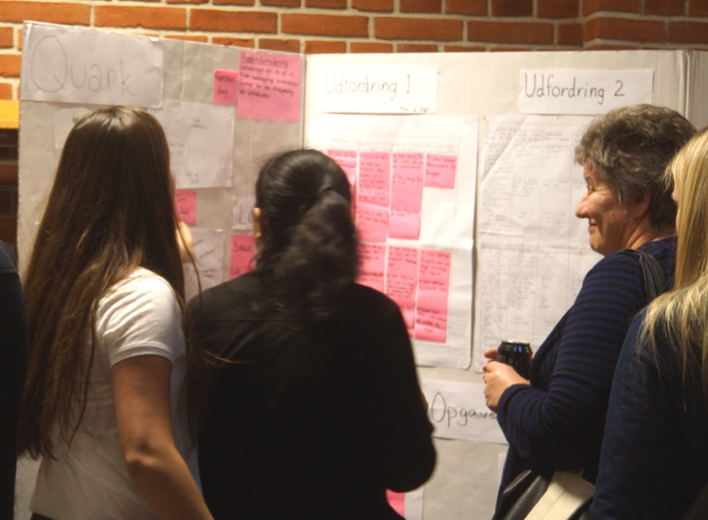
Students shows their work to the major of Hvidovre

Graphic facilitation – the unforeseen factor
As I mention in my method, I decided, with an intention of stumbling upon an unforeseen factor, to use a general interview guide approach. I did stumble upon an unforeseen factor. On the fifth day, while I was conducting a student interview I realised that the students kept pointing and referring to the “project wall” (figure 10).

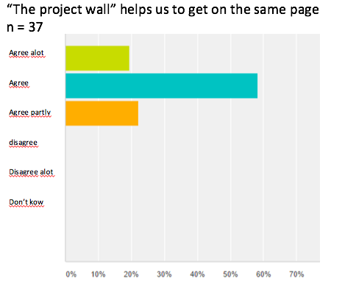
Statements like: “The project wall is where we have our common thoughts” and “The project wall helps us to get the full picture of our process” (focus group interview, day 5) got me thinking - I need to look in to these project walls and graphic facilitation.
Figure 10 - Photos of the project wall from the students’ digital logbooks.
Graph 1 – digital questioner day six.
I conducted a digital questionnaire on the sixth day and included the question: “The project wall helps us to get on the same page”. Graph 1 shows that 100 % of the students agrees at least partly with this statement. This confirms my hunch concerning the importance of including graphic facilitation in my study.

Graphic facilitation is not a part of my original research design and problem statement. Nonetheless, it has turned out that this aspect needs to be addressed.

Ole Qvist Sørensen underlines: “Visuals help the brain to make complex things tangible and enable us to grasp the complex” and “graphic facilitation is toll to get people on the same page” (Qvist-Sørensen, LAICS seminar November 2015).
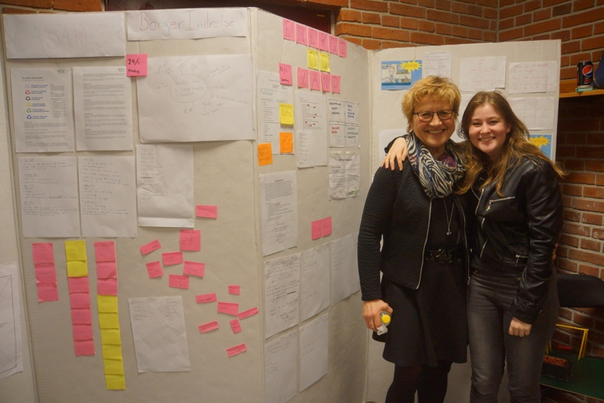

This relates to the works of Hanne Adriansen who argues that graphic facilitation helps the individual to “rediscover” a process. This allows the individual to reflect on the process and thereby take ownership (Adriansen, 2012). Heron and Reason’s relate graphic facilitation to knowledge through the term Presentational knowledge - an intuitive grasp of the significance of patterns as expressed in graphics and other art forms. I will, on the basis of the mentioned theory, elaborate on this topic in the analysis chapter “The project wall”.

Sum up - theory
The findings of the examination of the theory enables me to elaborate on research sub-question number one: What skills are involved in innovation competences?
I have learned that Jan Alexis Nielsens (Nielsen, 2015) five innovation competences can be seen as a useful tool to analyse a primary and lower secondary school student’s innovation competences. Additionally, Lotte Darsø’s four innovation roles (Darsø, 2011) can be used as a constructive description and guideline to how an “innovative student” interacts with others.

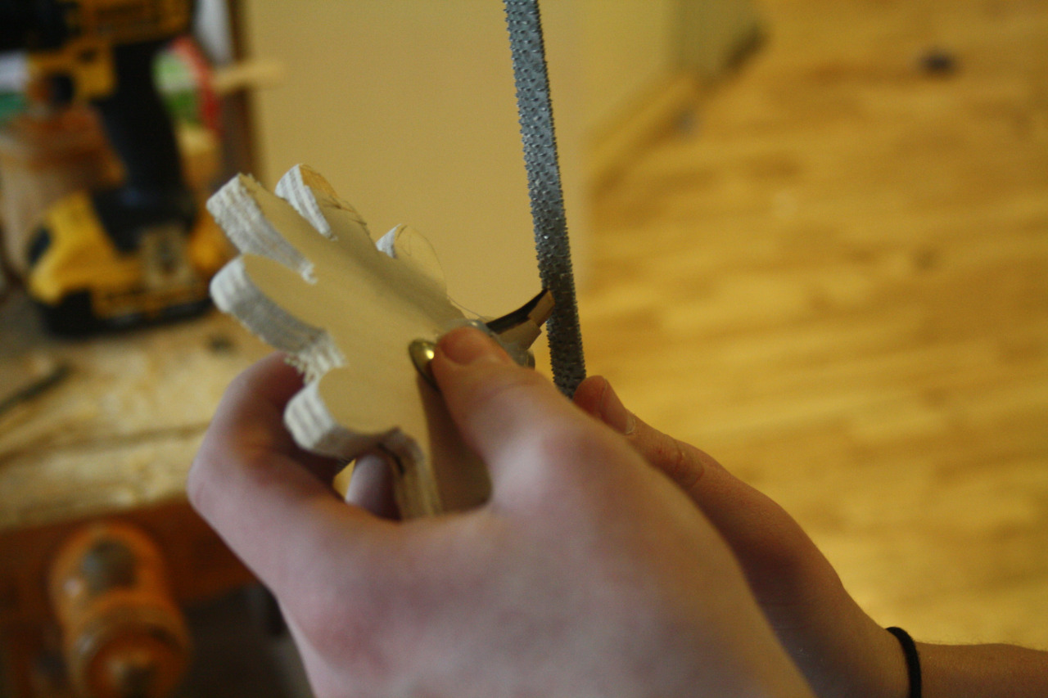
Student producing a prototype
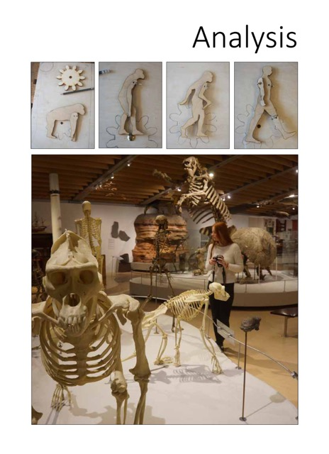

Analysis
The examination of theory has provided a theoretical framework which enables me to conduct an analysis that will address the following main themes:
- Analysis of the students’ innovative competences.
- Analysis of how ClimateZircus affects the students’ interest and motivation.
- Analysis of how ClimateZircus affects the learning environment.
- Analysis of how Graphic facilitation affects the students’ group work.

The innovative competences
The objective of this chapter is to assess, through Jan Alexis Nielsens five innovation competences and Lotte Darsø’s four innovation roles, if I can detect growth in the students’ innovation competences. This will be done on the basis of the digital questionnaires and the focus group interviews with students, teachers and a local business (appendix 2-7).

I commence my analysis by focusing on Darsø’s four innovative roles and will return to elaborate on the five innovative competences.

The Diamond of innovation
This chapter will, by applying Lotte Darsø’s four innovation roles (Darsø, 2011), shed light on how the students interact with the involved partners. Doing the transcription, it became clear to me that it is constructive to divide the process into the three sections; Before, Under and Presentation.
Figure 11 and the following analyses are conducted on the basis of my interview with local business, students, teachers, the consultant and my experience from facilitating ClimateZircus projects throughout the last four years. Figure 11 provides an overview of the interactions and roles of the partners.

 | Before | Under | Presentation
Students | No role | Jester/Challenger/Gardner | Conceptualizer
Teacher | Jester | Gardner/challenger/jester | Jester/gardener
Local business | Challenger | Gardner | Challenger
Consultant | Gardner/conceptualizer | Gardner | No role

Figure 11

Before
In this part of the process, the teachers and local business are finding a common understanding of how the project will unfold. The teachers try to understand what expertise the local business can bring to the table. The teachers acts like a jester and ask burning, hypothetical and crooked questions.

The local business acts like a challenger and tries to answer the questions by screening the business' knowledge. They ask rude questions like: “do the students have the ability to handle a second degree equation?”.

The learning consultant’s role is to facilitate the meeting between the two partners and clarify the concept of ClimateZircus by using examples from previous co-creation projects. It seems that the consultant’s role is a mix between a gardener and conceptualizer.

Under
As the students commence the innovation process they are in the area called ignorance (figure 8). They act like a jester and collect data by asking the local company naive, burning and hypothetical questions. They move towards the area called knowledge as the process unfolds, and turn to act like a challenger. They visit the local company, seek knowledge, collect general facts and ask the local business about underlying assumptions.
The local business acts like a gardener and will try to create positive relations by helping the students to get in touch with the right people. I have interviewed Kristian Mandrup Pedersen who is the daily leader of the visitor’s service at BIOFOS. A visitor’s service that has 12,000 visitors a year.

He expressed that the students he mentored were well-prepared and had positive attitude towards the visit. He also stated that

“I experienced that they, compared to other school classes, were very independent. They literally had no need for the teacher who accompanied them. They cleaned the laboratory after use - which is often our biggest problem. They documented their visit with pictures and asked questions which were prepared in advance.” (Kristian Mandrup, interview, day five).

I interpret this as an indication, that The Compass and the structured interactions with a local business stimulate the students’ work ethic and their capabilities to interact with their surroundings. The teacher is the students' supervisor and will be a mix of jester/gardener/challenger.

It depends on the group dynamics. Some groups need help with the energy level or group climate, others need help with asking the dumb and impossible questions and a third group needs a supervisor who acts as a challenger.

The consultant has no role, but will always contact the teachers and local business to do a bit of gardening by asking how the process unfolds.

Presentation
The students present their designs by clarifying, illustrating and describing their design concept. This puts them in the role of a conceptualizer. The local business collects the data and screens the presented concept for knowledge. They act as a challenger and try to understand if the design can bring value the company.
The teacher is interested in getting to know the strong points in the presented design and provides a positive situation for all involved in the presentation - like a gardener. The teacher also gathers information by asking hypothetical, burning and naive questions - like a jester.
This analysis indicates that the involved partners switch roles throughout the project. On average, people were to switch between 3 different roles, and all four roles were used at least 3 times. The most surprising aspect, from my point of view, is that the students, teachers and local business tend to share the roles between them - when a student acts as a jester, the business acts as a challenger and the teacher acts as a gardener. 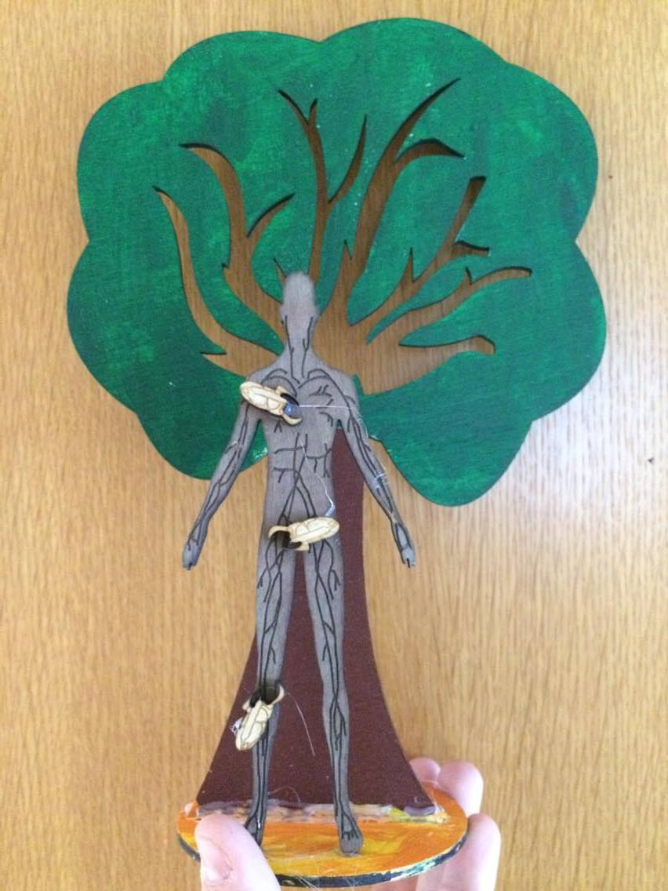
Part of student product
The Diamond of Innovation (Darsø, 2011) and the four innovation roles have helped me to understand how the students, teachers and local business interact, but it cannot tell if and how ClimateZircus develops the five innovations competences (Nielsen, 2015).

The Upper Secondary School Thought over Again
As I argue in the theory chapter “Innovation”, a student’s innovation competence can be analysed by focusing on Jan Alexis Nielsen’s five competences (Nielsen, 2015).

Figure 12 contains quotes from my interviews with and questionnaires of the students and teachers which I interpret as a sign of growth within the given competence.
Action competences | - They contact and seek knowledge from a wider area of knowledge domains (teacher, interview, day five)  - Increased my sense of ownership and help to be self-employed (student questionnaire day ten)  - I learned how to contact a business and the “outside world” (student, questionnaire, day ten)  - I learned to deal with the “real work life” and my ideas can come to life (student questionnaire day ten)  - The students learn to contact the “real world” (teachers, interview, day one)  - The students have started to contact people outside the school. They understand that they can get information from other sources than the library and google (teacher, interview, day six)  - The students have learned to solve a challenge that originated from the “real life”. This gives the students an amount of pride and confidence (teacher, questionnaire, day ten)  - Some learned to have the courage to do something unexpected (teacher, questionnaire, day ten)
Creativity competence | - The students are learning to network and share ideas (teacher, interview, day one)  - The assignments give us new ideas and perspectives (student, interview, day five)  - It made me think outside the box and taught me to be open to new ideas (student, questionnaire, day ten)  - The project wall has help the students to explain and develop ideas (teacher, questionnaire, day ten)  - They learned to generate ideas and select the right ideas (teacher, questionnaire, day ten)  - To have the patience to go through the entire innovation process before you develop your product (teacher, questionnaire, day ten)
Collaboration competence | - The students need to transfer the knowledge from the books to producing a product. This is done in collaboration with a company which means the students’ knowledge is related to the real world and is used to create value for others (teacher, questionnaire, day ten)  - They are more process--oriented and we have experienced that the weak students tend to get better grades. We think it relates to the fact that they can draw on the team’s strengths. The freedom to make your own choice and vast time to reflect on your work does also help (teacher, questionnaire, day ten)  - We are learning to network and share ideas (student, interview, day one)  - Innovation allows us to use the different competences of people in the group (student, interview, day five)  - The innovation process and assignments suggests a structure that helps us to communicate and work as a team (student, interview, day five)
Navigation competence | - The students learn how to use innovation processes (said by teacher)  - I have learned to dwell on an assignment and have patience with the process (student, questionnaire, day ten)  - We have learned to master innovation-process and tools (student, questionnaire, day ten)  - The students want to create a solution, but we try to get them to stay in the first two phases of the compass - the prepare and perceive phase. This is frustrating to some of the groups (teacher, interview, day five)  - The students have worked with different assignments to control an innovation process (teacher, questionnaire, day ten)
Communication competence | - The students are happy to present their work to the companies (teacher, questionnaire, day ten)  - It seems as if innovation tools like “De Bono’s thinking hats” and the visual aspect help the teams communicate (teacher, interview, day ten)  - The students learn to communicate (teacher, interview, day one)  - The innovation process and assignments suggests a structure that helps us to communicate and work as a team (students, interview, day five)  - We need to know what we present and how to communicate at the end of project, because the companies are experts know what we talking about (students, interview, day one)

Figure 12 – analysis of the students’ innovative competences based on Jan Alexis Nielsen’s five innovative competences.

Based on figure 12, I have arrived at the following four learnings.

- The students find it difficult to collaborate, but “The Compass” supports the majority of the students in doing so.

The teachers state, through the interviews and questionnaires, that the collaboration within the group has been a difficult but also a meaningful and fruitful learning experience. That apart, 25% of the students mention that collaboration has been the most difficult part of the process, and 1/3 of the students state that being able to collaborate is most important factor to a successful innovation process (questionnaire day ten).

Although the students find it difficult to collaborate, do they express that the “The Compass” has help them to collaborate.
This finding is supported by graph 2 and graph 3. The graphs show that most students find innovation relevant and more than 50 % mention that ClimateZircus methods have helped the students to collaborate.

The students’ logbooks uncover a similar pattern: “We started the day with an assignment called “De Bono’s Six Thinking Hats”. It helps us to structure our conversation. I it nice to have a space where you can talk freely about the negative and positive thoughts as well as generate new ideas.” (student, logbook, day four).

On the basis of the above, I assess that the students find it difficult to collaborate, but “The Compass” supports the majority of the students in doing so.

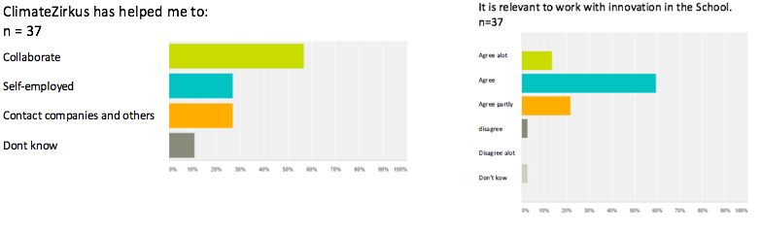 Graph 2 & 3 – questionnaire, day six
- “The Compass” enabled the students to keep focus on the innovation process and generates a navigation competence.

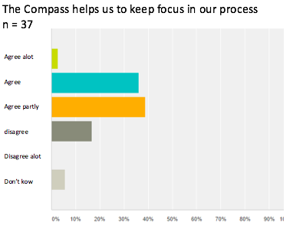
Graph 4 shows that approximately 78 % of the students who answered the questionnaire either agree a lot, agree or agree partly with the statement: The compass helps us to keep focus on our process. This indicates that the processes and assignment used in “The Compass” support the development of the student’s navigation competence. The following two quotes support this, and they imply that the students have learned to assess which information is critical for decoding an issue and solving a task.
Graph 4 - Questionnaire, students, day six

“We have found our target audience and other information. The innovation process has helped us a great deal.” (Student, questionnaire, day ten) and “I have learned to think more innovative, think big, work in chaos processes and be more patient.” (Student, questionnaire, day ten).

Furthermore, the quotation below gives evidence, that the teachers assess, that the introduction of “The Compass’” innovative methods has improved the students’ process handling skills.

“They are more process oriented and we have experienced that the “theoretical weak” students tend to get better grades. We think it relates to the fact that they can draw on the team’s strengths. The freedom to make your own choice and vast time to reflect on your work also helps.” (teacher, questionnaire, day ten).
Part of student product

On the basis of the above, it seems that “The Compass” to some degree develops the students’ navigation competence. And, up to a point, supports the students in taking ownership of and planning the complex work process.
- The assignments related to “The Compass” enable the students to develop new ideas.
Graph 5 and 6 show that the majority of the students state that ClimateZircus and its innovative methods boost their ability to create and communicate new ideas.

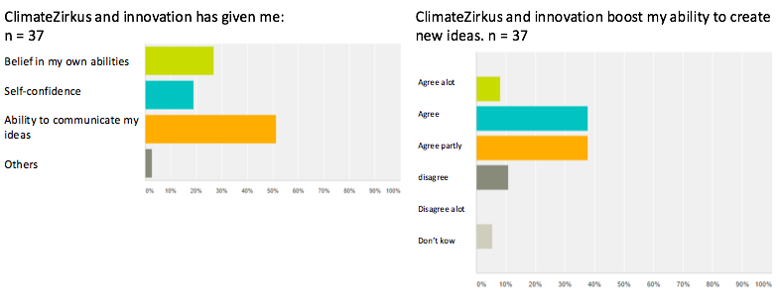
The quotations given indicate that the students learn to be open to alternative ideas and new solutions. “The students are learning to network and share ideas” (teacher, interview, day one) and “The assignments give us new ideas and perspectives” (student, interview, day five). Further, the next two quotations indicate that the students learn to assess, sort and expand ideas. This enables them to interpret and challenge issues.
Graph 5 & 6 – questionnaire, student, day six

“It made me think outside the box and taught me to be open to new ideas.” (student, questionnaire, day ten) and “To have patience to go through the entire innovation process before you develop your product.” (teacher, questionnaire, day ten).

The above shows that empirical data originating from questionnaires and focus group interviews with students and teachers suggest, to a certain extent, that the students have increased their creativity competence.

- The teachers developed an understanding of their role and focus on education through innovation
I have earlier introduced the Isi project. A research that points out that teachers who have worked with innovation processes tend to develop a focus on education through innovation rather than for innovation.

Education for innovation is an educational approach with great focus on the result/product of the process. In contrast to education through innovation has a process-oriented focus (Sølberg, J., et al., 2015, p. 216).

I have, through the teacher focus group interview, found a similar pattern: “I have become a teacher with focus on facilitating the students’ own innovation and learning process … I now have patent on the process but have let go on the product … I give the student a lot of freedom and responsibility. Some grow with this experience and others need a hand, but the guidelines of the Compass help the “theoretical weaker” students to get through the project.” (teacher, interview, day six). The sentence illustrates a teacher who has started to focus on the students learning through the innovation process – not on the product.
On the basis of my background as an educational consultant and professional teacher, I assess that education through innovation is a beneficial focus.
This can lead to a focus on how the students learn to master the different assignments and to navigate in phases of an innovation process. By having focus on the process, rather than a focus on a perfect product, allows the students to fail and learn from their faults. It helps the students to understand that not all innovative projects have a fruitful product, but the reflection upon processes enables the use and be a part of an upcoming innovation process. This is, in my opinion, the foundation of a learning environment which enables the student’s innovative competences to flourish.

On the basis on the above, I assess that ClimateZircus and The Compass provide a framework which to some degree enables students to increase and develop the five innovative competences. Further, it is my opinion that we need to consider innovation as a set of teaching methods and techniques that can support the development of a student’s generic skills and thereby strengthen the academic standard.

Sum up – innovative competences
Part of my problem statement asks “in which way does the innovation project ClimateZircus increase the students’ innovation competences” and research sub-question number 1 asks: “what skills are involved in innovation competences”.
My theoretic examination elaborated on what skills are involved in innovation competences. This showed that Jan Alexis Nielsen’s (Nielsen, 2015) five innovation competences and Lotte Darsø’s four innovation roles (Darsø, 2011) could be used as constructive tools to analyse the students' innovation competences.
The result of the analysis based on Darsø’s four innovative roles showed that the structure of ClimateZircus to some degree enables the students to pratice and use the four innovative roles. It seems to be fruitful to introduce, in future projects, the students, teachers and local business to the four innovative roles.
Although, the five innovative competences originate from the upper secondary school, they have proven to be a useful lens for analysing a primary and lower secondary school student’s innovation competences. Although, it one thing that it is a constructive analytic lens, but is it also a tool which a municipal primary and lower secondary school teacher can use to plan and execute an education that develops the student’s innovation competences? My guess is yes - if the five competences are adjusted to fit the cognitive level of students at the primary and lower secondary school.
However, my research does not provide empirical data to answer this question. Yet, it is an interesting topic for future research.
The two analyses clarify that ClimateZircus’ methods, structure and framework train the student’s capability of handling an innovation process. That apart, ClimateZircus introduces the students to a learning environment that allows them to develop their innovation competences.

Interest and motivations
I argued, in the theory examination, that the TPMC allows me to analyse how ClimateZircus affects the students’ motivation and creativity. TPMC also enables me to estimate if the students can be categorised as being on a mission, a treadmill, an expedition or on autopilot. Figure 13 explains how the four categories are defined.
Figure 13 - Amabile Hadley, K. & Kramer, S.J., 2002
This leads me to an analysis of the conditions of the framework that ClimateZircus provides for the students’ motivation and creativity. The analysis is based on the student questionnaire from day ten (appendix 4), the focus group
interview from day one and five (appendix 2 and 3).
When I apply TPCM to the data, I get the following result (figure 14):

An expedition  - we will learn things needed in the real world. | A mission  - nice that we get to work with experts (student, interview, day one)  - motivating to see the “inside” of a company (student, interview, day one)  - a nice break from the “normal” school (student, interview, day five)  - we need to be able to work together, use logic and listen to others (student, interview, day five)  - we will learn something we can’t learn from the teachers (student, interview, day one)  - we need to know what we present at the end of project, because the companies are experts know what we talking about (student, interview, day one)  - that it will be relevant, interesting and currently (student, interview, day one)  - that it is more “real” (students, interview, day one)  - motivating that we can, maybe, solve problems and help the local community. It makes me feel a greater ownership to my project (students, interview, day one)  - that we need to know what we present at the end of project, because the companies are experts know what we talking about (students, interview, day one)  - cool that the learning is generated outside the classroom (student, interview, day one)  - It increased my sense of ownership and help to be self-employed (student, questionnaire, day 10)
On Autopilot | A treadmill

Figure 14
My immediate assessment is that the students can be categorised as being on a mission. A mission is described as a: “condition for achieving creativity on the high-pressure days was interpreting the time pressure as meaningful urgency. People understood why solving a problem or completing a job was crucial, and they bought into that urgency, feeling as though they were on a mission” (Amabile Hadley, K. & Kramer, S.J., 2002).

This allows me to assume that the ClimateZircus structure and methods put forward good conditions for focus, creativity and meaningful urgency.
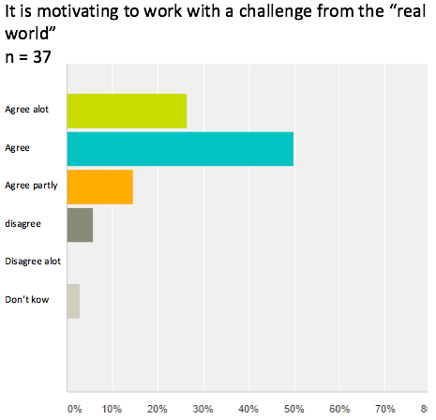
This finding is supported by graph 7. The graph revels that approximately 85 % of the students who answered the questionnaire either agree a lot, agree or agree partly with the statement: “it is motivating to work with a challenge from the “real world”.
Graph 7 - questionnaire, student, day six
This leads me to gauge that the students might be working with in their zone of proximal development - which is supported by the quote: “I think that a lot more students will be able to contribute… Normal assignments focus on an academic content like spelling and calculating, but I think innovation opens up for the use of different competences.” (student, interview, day one).

My examination of theory concerning a student’s interest in an educational situation revealed that an interest is always a dynamic mix between the situational and the more conscious individual interest (figure 4).

The above has disclosed that the students find it motivating and relevant to innovate with a local business. I view this as an indication that the framework, structure and methods used by ClimateZircus to some degree generate and stimulate an individual interest. This interpretation is supported by the following two quotes: “I think that ClimateZircus makes sense because we have a chance to meet a workplace and figure out if it relates to our own work future.

We also have a possibility to work with a “role model”. This gives an understanding of some of the problems they have and that we actually can try to help them.” (students, questionnaire, day six) and “It is interesting that we can, maybe, solve problems and help the local community. It makes me feel a greater ownership to my project” (student, interview, day one).

Sum Up – interest and motivation
The above allows me to elaborate on research sub-question number 2 concerning how ClimateZircus and its methods affect the students’ interest and motivation. It is, based on the TMCP analysis, my assessment that the project puts forward constructive conditions for creativity and meaningful urgency. Further, it seems that the collaboration with a local business and the methods used in ClimateZircus have a positive effect on the majority of the students' interest and motivation.

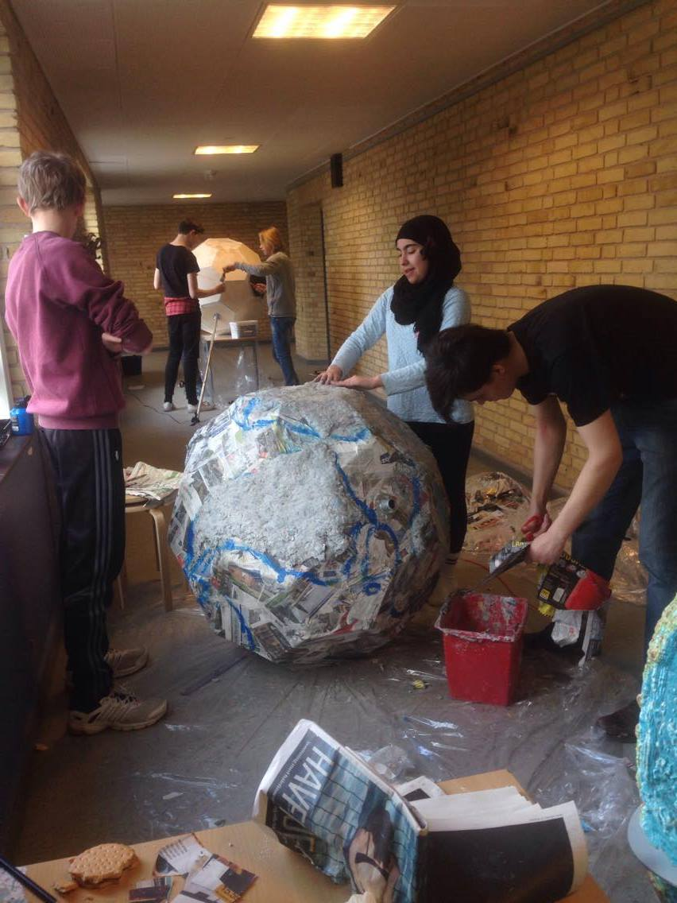
That apart, ClimateZircus has a tendency to generate a student’s individual interest – an interest described as conscious and lasting. Although, as with all educational methods, innovation and the collaboration with the local business do not appeal to all students. Some students do not like change and feel comfortable with the “old” methods. This is seen in a sentence like:

“My opinion is that it doesn’t make sense (to work with companies). We used to write a problem statement from a superior topic – which has worked outstanding. I do not understand why we have to use extra energy and contact companies when we can write an assignment without it – as we use to” (students, questionnaire, day ten).

It is, with this sentence in mind, fair to assess that the project has benefited some students more than others. Yet, I can conclude that 85 % had a positive and meaningful experience (graph 7).

The TPCM and the zone of proximal development has been a resourceful tool to analyse how ClimateZircus affects the students’ motivation and interest. However, to get a deeper understanding of how the learning environment is affected I will, in the following chapter, introduce WRS and LRS.

The learning environment
I will use this chapter to examine, through LRS and WRS, research sub-question number 3 and the part of my problem statement which relates to how ClimateZircus and innovation processes might affect the students’ learning environment.
Yet, prior to commencing the examination, I want to give an example of the authentic learning environment that ClimateZircus offers.

“We started a very chaotic day with problems right from the beginning of the day. We lacked two from our group and had to visit a recycling plant… We accidently got off the bus to early and had to walk 2 km. As we arrived at the recycling plant, we realised that we had no agreement about and permission to film at the plant. Patrick then had to call 15 people to find out what had happened. Finally, we got hold of our professional mentor who help us and gave us permission to film. As we arrived back at the school some group problems came to the surface. Everything bad came out and the group members were really going at it. The teachers helped us to sort out the situation. It was a chaotic day.” (student, digital logbook, day three).

The statement illustrates a complex learning environment that pushes the students to the limit of their zone of proximal development. Further, the students are forced to use their navigation, collaboration and action competences to deal with the obstacles. The students describe the day as a chaotic day, but the fact is that they deal with the difficulties and get through the day. This is probably because the teachers and professional mentor help and support the group every time it is about to crumble.

I asked the teachers: “Do the students learn the same as in a regular lesson?” and got the answer: “No, the students use their skills in an authentic context. They work more process-oriented, and we experience that that students tend to receive a higher grade. ClimateZircus’ structure allows the students space and time to immerse themselves in the work, and utilise each other's different assets and skills.” (teacher, questionnaire, day ten).

You cannot replicate the real world in a classroom and it seems that the students have learned a thing or two that they could not read in a book. That apart, the above supports the participation metaphor (Sfard, 1998), a metaphor for learning that perceives an individual as being an active participant in a specific social practice.

LRS – Learning Rating Scale
Learning Rating Scale (LRS) is a tool that generates qualitative data. The data generated with LRS enables me to the examine to which extent the students experience the quality of the learning situation (Nissen, 2012). The scale consists of 4 lines and the idea is to ask your students to express on a scale from 0 to 10, (1) how is the level of the four areas: 1) academics, (2) how is the social life, (3) how the methods suit students, and (4) is the level of expectation suitable (figure 9).
The four numbers add up to a cut-off score.

The student does not experience a fulfilling learning situation if the cut-off score is below 32.

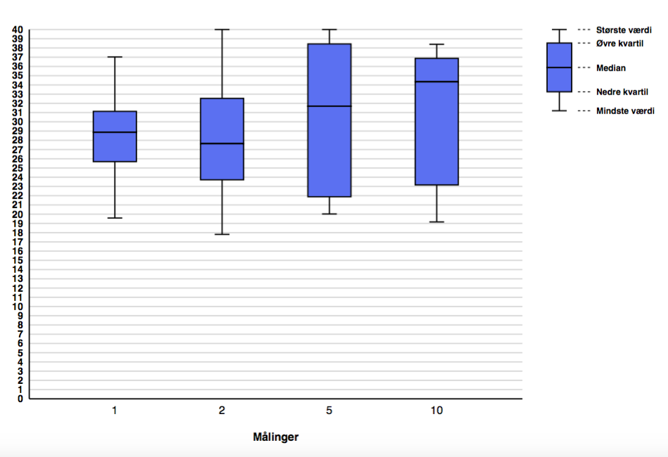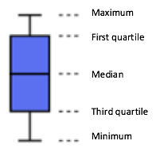
Day

Figure 15

Figure 15 shows the result of the LRS test via four boxplots. A first glance discloses that the first quartile and median of day one is below 32.

This tendency changes throughout the process, and on day two the first quartile score is 32.5, but the median score is 27.6. The boxplot for day five has a first quartile of 38.4 and a median of 31.7. Furthermore, day ten has a first quartile of 36.9 and a median of 34.3, i.e. both above 32.

 | Day 1 | Day 2 | Day 5 | Day 10 | Change
First quartile | 31.1 | 32.5 | 38.4 | 36.9 | + 5.8
Median | 28.9 | 27.6 | 31.7 | 34.3 | + 5.4
Third quartile | 25.7 | 23.7 | 23.2 | 23.2 | - 2.5
Graph 8
Graph 8 and figure 15 disclose that the first quartile and the median of day one are below 32, which indicates that at least 75 % of the students do not have a fulfilling learning experience.

Yet, is both the first quartile and the median are above 32 at the tenth day. This indicates that at least 50 % of the students do have a fulfilling learning experience. The third quartile starts at 25.7 and decreases by 2.5 throughout the project.
A boxplot offers a constructive method to compare different sets of data. Yet, it is important to know its limitations. It shows the first quartile (25% highest scores), median (50% highest scores), third quartile (25% lowest scores), minimum (the single lowest score) and the maximum (the single highest score).

The down side of a boxplot is that you cannot register the spread of scores within the different quartiles. This is sometime a challenge.

One example is the large difference between the score of the median and the third quartile of day ten. The score of the median is 34.3 and the third quartile has a score of 23.2. The issue is that I can register that some of the students from the third quartile are above 32, but that I cannot tell how many.

The analysis above has showed that ClimateZircus has an effect, but yet diverse influence, on the students’ learning experience.

On the basis of figure 15 and graph 8, I see that ClimateZircus has generated a positive learning experience for the majority of the students. Figure 15 offers a general insight, but cannot give me any insight into the changes in the different four areas which LRS measures. I will use a web chart to examine the four areas separately.

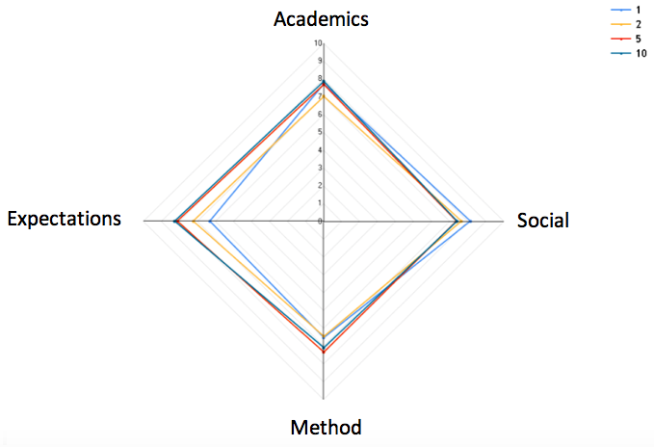
Figure 16 – LRS web chart
 | Day 1 | Day 2 | Day 5 | Day 10 | Change
Social | 8.2 | 7.6 | 7.4 | 7.4 | - 0.6
Expectations | 6.1 | 7.2 | 8.1 | 8.1 | + 2.0
Method | 6.5 | 6.4 | 7.1 | 7.3 | + 0.8
Academics | 7.7 | 7.0 | 7.7 | 7.9 | + 0.2
Graph 9 – LRS scores from figure 16

My transcription and analysis of the interviews and questionnaires disclosed that the students found it challenging to collaborate. I find a similar pattern through the LRS data in graph 9.

The graph reveals that the social score has decreased by 0,6 point. I view this as an additional indication that the collaboration has been challenging – yet fruitful.

The web chart unveils an increase in the areas expectations, methods and academics. The increase in the LRS-scores, I have detected via the boxplots in figure 15, mainly relies on an increase in the areas expectation and method. The following student quote and graph 7 support and elaborate on the growth. “we need to know what we present and how to communicate it at the end of project. The companies are experts and know what we are talking about.” (students, interview, day one). My assessment is that the co-creation between the students and the local business has a positive effect on the arena expectations.

WRS – Wellness Rating Scale
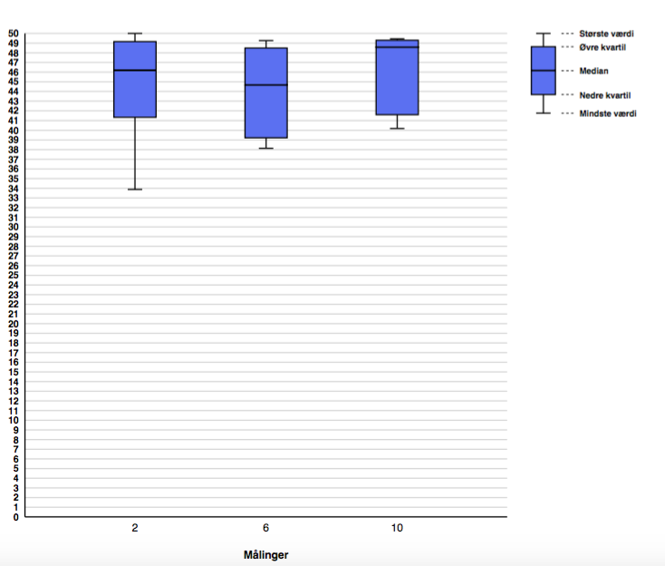
The WRS measures the students’ wellness by focusing on five areas 1) the local environment, 2) the school, 3) the friends, 4) the family and 5) the child’s self-esteem. The student grades the five areas with a score from 0 to 10, and the scores are added up (figure 9). This provides a cut-off score that is acceptable if a student scores 46 points or more. If the students score between 38 and 46 from a border area and a student with a score between 37 and 17 is concerning and the teacher should start a dialog (Nissen, 2011).
Day

Figure 17

 | Day 2 | Day 6 | Day 10 | Change
First quartile | 49.2 | 48.5 | 49.3 | + 0.1
Median | 46.2 | 44.7 | 48.6 | + 1.8
Third quartile | 41.2 | 39.2 | 41.3 | + 0.1
Maximum | 50 | 49.3 | 49.4 | - 0.6
Minimum | 33.9 | 38.1 | 40.2 | + 6.3
Figure 17 and graph 10 show change in the median, minimum and maximum. The maximum score declines by 0,6 points, but is still above 46 and within the area that is categorise as acceptable. The median starts at 46.2, drops to 44.7 and ends at 48.6 (Graph 10).

Graph 10

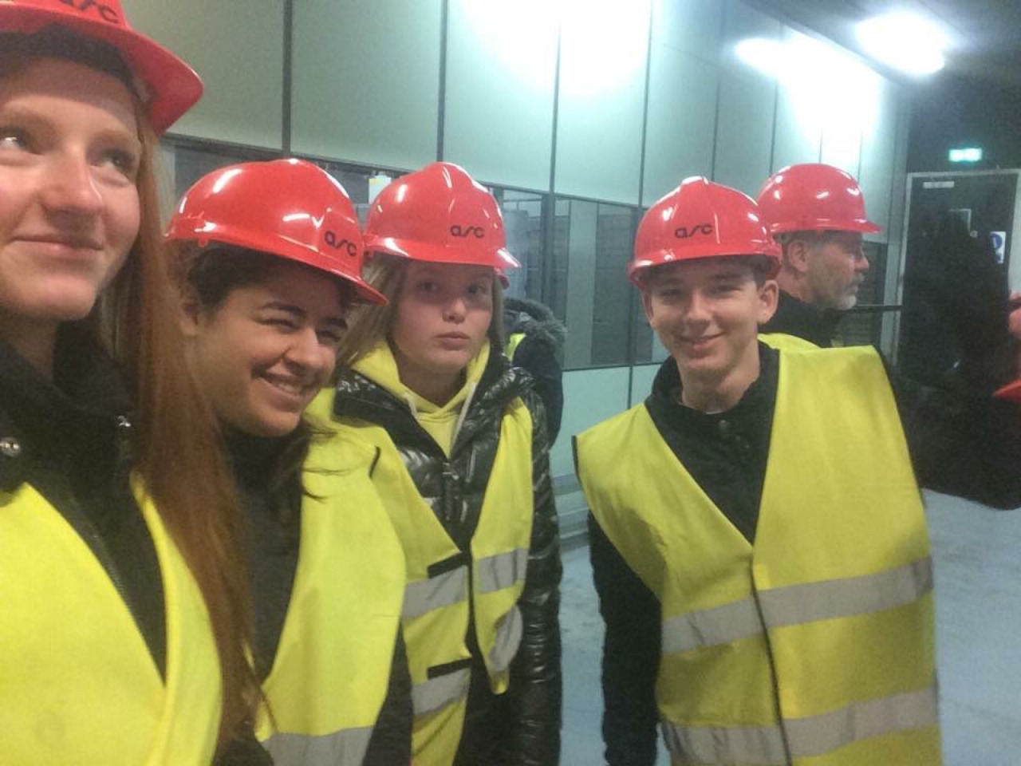
The students are visiting ARC

I detected the same pattern in the LRS test (figure 15) and I have wondered why this pattern accrues. To seek an explanation, I examined the students’ logbooks and found the following text sequence:

Day 2 | Student quote:  We have produced a mind map related to our problem. It was difficult given that we had misunderstood what we should do, but fortunately we have corrected it now. | My interpretation:  The students have difficulties understanding the assignments.
Day 3 | Student quote:  The morning started with a task with a man and a dog. We also found some words from our mind map. Afterwards, we code words together and come up with a metaphor for our problem statement. There were some things we misunderstood, but we got through the day. | My interpretation:  The students have difficulties understanding the assignments.
Day 5 | Student quote:  This morning we were all a bit confused, but after we talked with the teacher we used the six thinking hats ... it was fine because we got a better idea of what we should do. | My interpretation:  The students have difficulties understanding the process.
Day 6 | Student quote:  When the day started, we thought we had gotten nowhere, because all we did last week was a lot of different exercises. But we have realised that the exercises have actually helped us, and we've got a lot of material that we can use in our presentation. | My interpretation:  The students realise the connection between the assignment and the process.
Day 9 | Student quote:  We have had a feeling of not getting anything done, but we can now see that we are doing well, and we can see the goal line of the project. We just have written the last piece of text. Also, we are ready to present and we are really nervous, but at the same time super excited!! | My interpretation:  The students used the learnings from the innovative assignments and processes to produce a “product”.

Figure 18 – Student, logbooks, http://cami273i.tumblr.com/ and http://majjblog.tumblr.com/

The text sequence reveals that the students do not understand the innovation assignments and are uncertain of how to deal with the process. Although, at day six the penny drops and they realise how the assignments connect with the process. This pattern is supported by these students quotes:

“It was difficult because we have not used an innovation process before.” (student, interview, day five) and “Initially the influence (of “the compass”) was not so good - it was frustrating. Later in the process “the Compass” was a very positive influence.” (students, questionnaire, day ten), further “The Compass and the assignment is a good tool, but it is frustrating that we haven’t started to produce a product.” (student, interview, day 5).
Figure 18 and the three quotes correlate with the patterns from the boxplots (figure 15 and 17).

My assessment, based on the above and my ten years of teaching-experience, is that the students are confused because they are not trained in using an innovation process.

They cannot construct a connection between their problem statement, the process and the assignments. Furthermore, the beginning of an innovation implies asking burning questions, research, questioning the facts, diverging and complexity. The students are insecure due to lack of innovative competences and knowledge related to the process. The school system needs to teach the students how to embrace the complexity of an innovation process.

I have, when I worked as a teacher, often experienced a student who felt uncertain of a complex task. Yet, too many times I have helped the student by reducing or removing the tasks complexity. I now realise, that we need to help our students to feel at ease with the complexity by developing their innovative competences and teach them methods to deal with it.

On day 2, the minimum is at 33.9 points, but on day ten it has increased by 6.3 points to a total of 40.2 points. A shift that moves the score from concerning to the border area.

Part of an explanation for this shift might be found in the following student quote: “I think that a lot more students will be able to contribute… Normal assignments focus on an academic content like spelling and calculating, but I think innovation opens up for different competences.” (Student, interview, day one)

The quote emphasise that all students have a better chance to contribute – also the ones who have difficulties with the “regular academics”.

My assessment, based on the theory of the zone of proximal development, is that the minimum cut-off score has increased, because the less the academic student has a feeling of being able to contribute. It is probably not the entire explanation, but this claim is supported by figure 19 and graph 11. They show that the largest increase is connected to the areas “How do you feel about yourself” and “The School”.

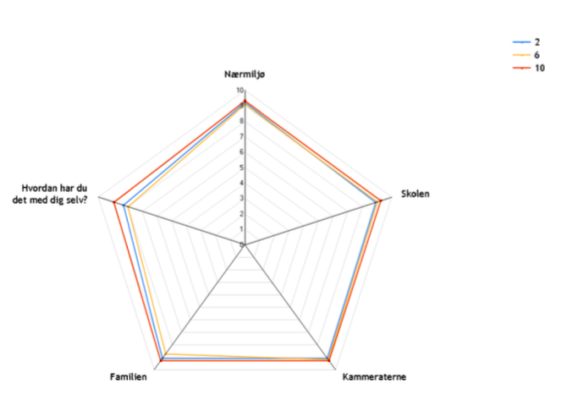
Local environment
The school
The friends
The family
How do you feel about your self?

Figure 19

 | Day 2 | Day 6 | Day 10 | Change
Local environment | 9.2 | 9.1 | 9.3 | 0.1
The School | 8.9 | 9.0 | 9.3 | 0.4
The friends | 9.1 | 9.2 | 9.3 | 0.2
The family | 9.1 | 8.7 | 9.3 | 0.2
How do you feel about your self | 8.3 | 8.0 | 8.9 | 0.5

Graph 11

Sum up – The learning environment
To sum up the learnings from my analysis of the learning environment of ClimateZircus, I assess that the students' meeting with the complexity of the “real world” forces them to work together and think on the fly.

The analysis revealed that at least 75 % of the students did not have a fulfilling learning experience at day one. Yet, at least 50 % of the students did have a fulfilling learning experience at day ten. I interpret this as, at day one, the students are insecure due to of lack innovative competences and knowledge related to the process. As the process unfolds, the students start to understand the process and the innovative competences develop. This leads to a change in how they rate the learning experience.

Furthermore, both the students and the teachers point out that being an active participant in the group is fruitful.

I, furthermore, assess that the meeting with an innovation process makes them insecure. I realise, that we need to help our students to feel at ease by developing their innovative competences and teach them methods to deal with it.

The project wall
I have asked the student “how did the project wall affect the group work?” (appendix 4). Thirty students answered the question and provided the following answers:
- It gave us a better overview of the process (18)
- It gave us a common understanding (8)
- It created a better focus (9)
- It helped to create ideas (2)
- We were afraid it was ugly (1)
- It didn’t have an effect. (7)
(student, questionnaire, day ten)

A first glance unveils that the graphic facilitation on the project wall helps the students to get 1) on the same page, 2) a common understanding, and 3) get a better focus. This endorses Ole Qvist Sørensen claim: “graphic facilitation is toll to get people on the same page” (Qvist-Sørensen, LAICS seminar November 2015).

I asked the teachers the same question and they answered (appendix 7):
- It has helped the students to have an overview of the process.
- It has provided some calmness in a project full of “chaos”.
- Help them to structure the work load.
- Help them to explain and develop ideas. (questionnaire, teacher, day ten)

The teachers mention that the Project Wall has helped the students to explain and develop ideas. This finding can be justified by Heron and Reason’s term presentational knowledge - a knowledge that can be expressed through arts or graphics. In this case, the students use the graphic facilitation to describe the significance of a pattern or an idea. This enables a student to express a complex string of thoughts through

the graphics. Furthermore, it provides an opportunity for the student and other members of the group to express the idea in words.

My assessment is, on the basis on the above, that the graphic facilitation of the project wall has helped the students to make the complex tangible. This has enabled them to grasp the complex and uncertain, and provided a calm oasis in the chaos.

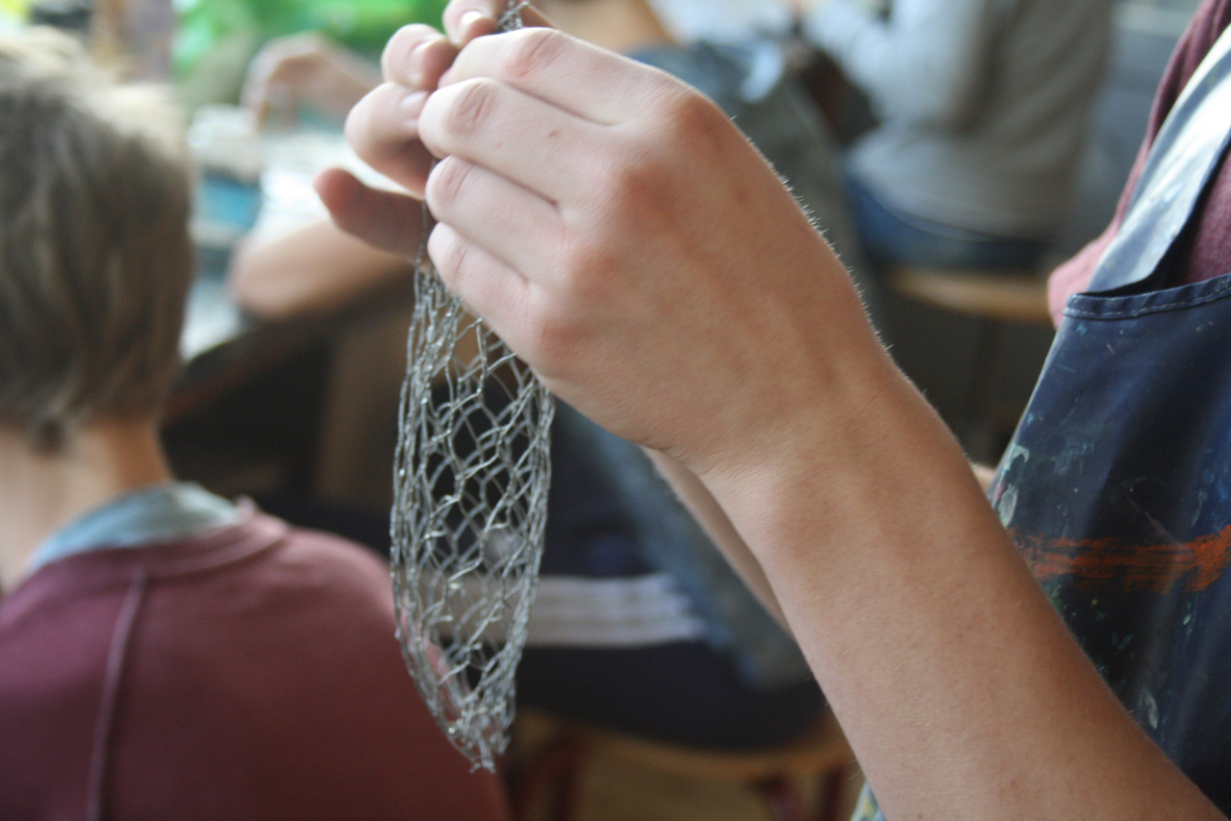
Students producing a prototype

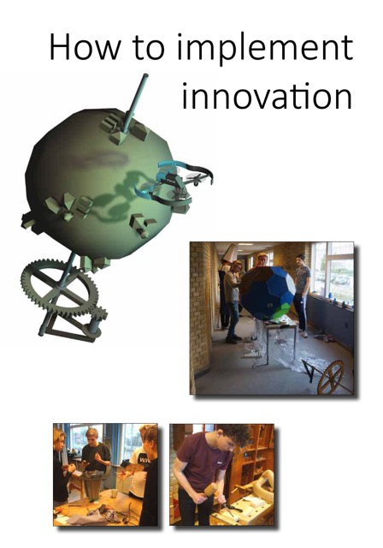

How to implement innovation.
My analysis has dealt with a local open school project, but how can my findings be implemented in a national agenda? The following chapter sums up and discusses my findings and provides a set of recommendations. The recommendations will focus on the municipalities and the primary and lower secondary school leaders and teachers. Prior to commencing the recommendations, I find it important to state that innovation and school/company collaboration are relatively new terms.

Nevertheless, the primary and lower secondary school system has a few different innovation methods, but to fully understand the potential of innovation and “The Open School”, the development of new didactics is needed. This is a process that needs to be kick-started, but a certain amount of patience is also needed. Evidently it demands time to develop and implement new didactics into a school system with 98 municipalities and about 2500 schools (uvm.dk). And if the objective is to implement innovation and the open school in a municipality, it is important to view the recommendations as a coherent set of recommendations.

Furthermore, it is essential to keep in mind, since I only deal with findings from my study, that the recommendations cannot be seen as adequate.

Municipalities
The school reform of 2014 (The Ministry of Education, 2014), integrates innovation in all subjects and encourages the schools to cooperate with local businesses.

The report “School/Company partnership – a part of the solution” (Deloitte, Engineer the future, 2016) has examined what obstacles the school/company collaboration has. The report points out that 1/3 of the asked companies want to collaborate with local school. Yet, they do not know:
- who to contact to get in touch with the local schools
- what tasks a cooperation with a school brings
- what assignments/knowledge is relevant to a student.

1. Hire a consultant to facilitate the process of the collaboration.
A possible answer to these obstacles is to hire a consultant who facilitates the process of the collaboration.

This claim is supported by the following three quotes:

“it is important to have a coordinator who handles the contact between the local business and the school. The facilitation takes up time and we need help to handle this task.” (Kristian Mandrup from BIOFOS, local business interview, day five)

“The projects become fragile and to depended on the decidated people” if different collaborations is not facilitated by a me” (Elizabeth Gray - innovation consultant, interview, day five)

“the collaboration demands a great amount of planning, and we use a person from the municipality to contact the local business - we can’t do it without her”. (teacher, interview, day five).

2. Contact Jet-Net or Astra.
The Municipality can seek help from Jet-Net.dk if the municipality neither have or can find the means to hire a local consultant. Jet-Net.dk is a nationwide network between businesses and primary and lower secondary schools. It has been created to awaken and stimulate children's and young people's understanding of and interest in science and technology.

Astra is a national origination whose vision is to give all young students insight and competences in science subjects, as a foundation for being an active citizen in the 21st century. They can support the municipalities progress and help to develop a strategy that implement innovation and open school project.

3. Set up a yearly series of meetings with focus on knowledge sharing between the school leader, teachers and local companies.
I recommend that the consultant is responsible for a series of meetings with focus on knowledge sharing between the school leader, teachers and local companies. The following teacher quote highlights the importance of the consultants.

“it is important that the team of teachers reserve time for common reflection with the coordinator” (teacher, interview, day one).

Primary and lower secondary school leaders
The school leaders have a responsibility for building an innovative culture at the local school. In doing so, I recommend that school leaders have focus on the following:
- Increase the teachers’ understanding of innovation processes and competences.
- Supply a structure that gives the teachers a feeling of being on a mission or expedition.

1. Increase the primary and lower secondary school teachers’ understanding of innovation processes and competences.
In my examination of the term innovative competences, I did not find adequate research on innovation competences connected to primary and lower secondary school students and had to find inspiration from the upper secondary school didactics. This showed that the primary and lower secondary schools in Denmark do not have an adequate understanding of innovation competences.
I recommend that the school leaders actively engage their teachers in the process of gaining a better understanding of innovation processes and competences.
My theoretic examination and analysis have shown that it is recommendable to build the implementation of innovation and “The Open School” on the five innovation competences (Nielsen, 2015), the Diamond Innovation (Darsø, 2011) and “The Compass” from Design to Improve Life Educations.
2. Supply a structure that gives the teachers a feeling of being on a mission or expedition.
The Time-Pressure/Creativity Matrix (Amabile Hadley, K. & Kramer, S.J., 2002) disclosed that, when dealing with creativity and innovation, it is constructive to have workers/teachers who have a feeling of being on a mission or expedition. To do so, I recommend that the leaders carefully match the teachers with jobs that have them working at the top of their competency levels, pushing the borders of their skills, and support the development of new competences.

Be careful not to allow too big a gap between staffs’ tasks and their abilities. ClimateZircus helped the school leader to deal with these criteria by using the municipalities local innovation consultant. The consultant taught the team of teachers new didactics.

She also helped the teachers to plan, carry out and reflect upon the difficulties in the project. The consultant had meetings with the teachers at the school and she did also have an active role during the interaction with the students. The Municipality of Hvidovre and the University College of Copenhagen called the model “Education within Education”.

Teachers
The LRS test, the questionnaires, and the student and teacher interviews did all point to the indication that the students did not (at the beginning of the project) have the necessary understanding of an innovation process.

To avoid this, I recommend that innovation does not become an isolated method we only use in an “innovation week” or projects like ClimateZircus. It is important that the mindset and assignments related to innovation processes become part of the daily lessons.

My claim is supported by this teacher quote:

“We need to use the innovation assignment in the normal lessons. This will preclude the students' frustrations and enable the students to understand the innovation process better.” (teacher, interview, day ten).

1. Focus on education through innovation
I recommend that the teachers focus on education through innovation.

The focus on the process allows the students to fail and learn from their mistakes. This helps the students to understand that not all innovative projects lead to a fruitful product, but the reflection upon the processes enables them to develop innovative competences they can use in the next innovation process. It is, as the following quote illustrates, a difficult task because the students tend to focus on the quality of their product: “it is difficult to find a balance between the importance of the final product and the process” (teacher, questionnaire, day ten).

2. Innovation is taught through participation.
This claim is supported by the text sequence in figure 18. The text sequence showed the progress of a student’s understanding of an innovation process. At first the student does not understand the process, but he reaches a deeper understanding of the innovation process, simply by participating in the process.

3. Train the students to collaborate in groups.
I know, on the basis of my experience as a teacher, that the Danish municipal primary and lower secondary school system focuses on collaboration in groups. Nevertheless, both students and teachers expressed, through the interviews and questionnaires, that the collaboration within the group has been a difficult but also a meaningful and fruitful learning experience.

I recommend, on the basis of the above, that the teachers prepare the students for innovation processes by helping and teaching the students to embrace and use the diversity within a group. Useful tools could be De Bono’s “Six Thinking Hats” or the assignment that is included in “The Compass”.

4. Use graphic facilitation to reduce the “chaos” and develop ideas.
My study of the graphic facilitation showed that the project wall clarifies an idea and creates a shared language and understanding. The visuals helped the students to make the complex things tangible. I recommend that the teachers introduce the students to graphic facilitation technics.

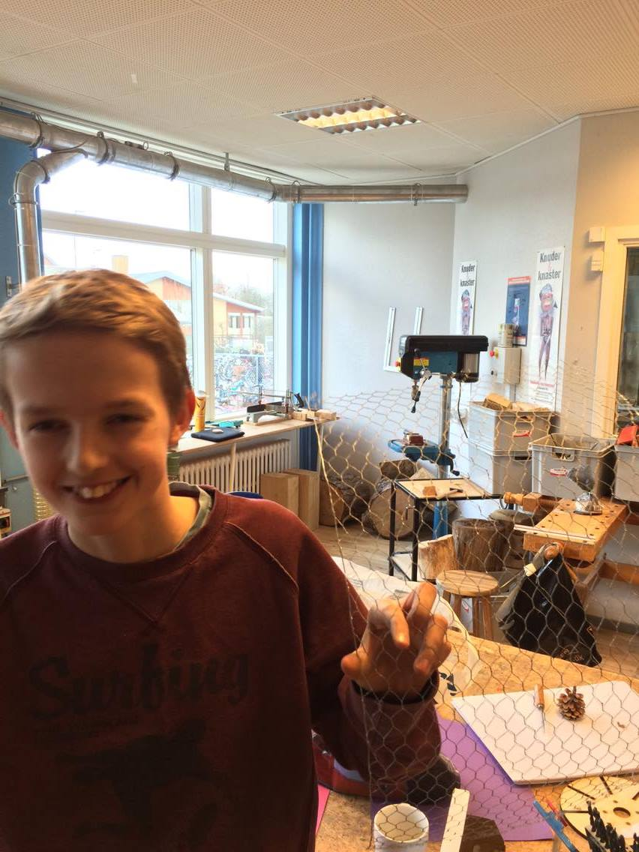
The following statements support the recommendation:

““The project wall” is where we have our common thoughts” and ““The project wall” helps us to get the full picture of our process”

“we use “The project wall” to post our assignments and ideas” (focus group interviews, students, day five).

ClimateZircus used the book “The visual teacher” and a drawing technique called “Star Men” from the company “Bigger Picture”.

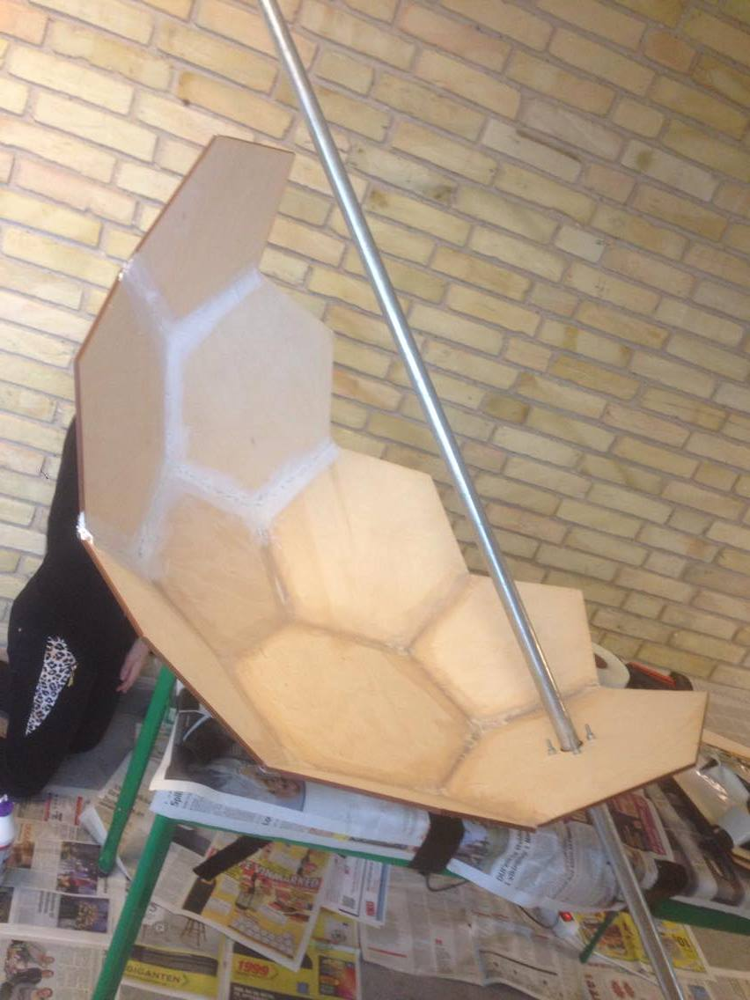

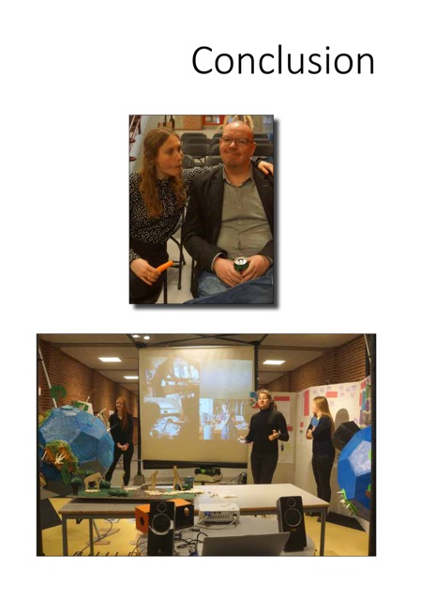

Conclusion
The practical purpose of this study has been to gain a deeper understanding of how the agenda “The Open School” and innovation processes affect the students in the primary and lower secondary school. I have, through a case study, analysed the local innovation project ClimateZircus which have provided input and empirical data to the content concerning the above.
My assumption, which origins from my experience with innovation projects similar to ClimateZircus, is that the students learn different things and in different ways in innovation processes which are authentic and realistic because they are based on collaboration with a local business and their real-life challenges. This inspired me to construct a problem statement that asked the following questions:
- In which way does the innovation project ClimateZircus increase the students’ innovation competences?
- How does an innovation process affect the students' learning environment?
- What type of learning is generated?

I will in the following, to avoid repeating myself too much, focus on answering the problem statement and research sub-question. Other findings are described in my set of recommendation and sum ups.
The theoretical framework is constructed to describe and conduct the analysis of the students’ innovation competences and, among others, builds on the works of Jan Alexis Nielsen and Lotte Darsø.
My findings show that the five innovation competences 1) action, 2) creativity, 3) collaboration, 4) navigation and 5) communication competence are a useful lens for describing and analysing a primary and lower secondary school student’s innovative competence.
Although it gives a constructive analytic perspective, it does not necessarily work as a tool for a primary and lower secondary school teacher to plan and execute the type of education that develops the student’s innovative competences.
I suggest that it would be fruitful to conduct further studies concerning this topic.

Additionally, can Lotte Darsø’s four innovation roles 1) the gardner, 2) the jester, 3) the conceptualizer, and 4) the challenger (Darsø, 2011) can be used as a constructive description and guideline to how an “innovative student” interacts with others.
Based on my analysis, I conclude that the structure of ClimateZircus and the framework "The Compass" to some extend develop the students' innovation competences and train their capability of acting in and handling an innovation process.
Research sub-question two deals with how ClimateZircus affects the students’ interest and motivation. I have used TMCP as a lens to focus on this perspective, which has enabled me to conclude that the project puts forward constructive conditions for creativity and meaningful urgency.
Additionaly, the collaboration with a local business combined with the innovative processes have a positive effect on the majority of the students' interest and motivation. It seems that ClimateZircus has a tendency to generate and stimulate an individual interest.
The analyses related to how an innovation process affecting the students' learning environment are based on LRS and WRS tests. The LRS test revealed that at least 75 % of the students did not have a fulfilling learning experience at day one. Yet, at least 50 % of the students had a fulfilling learning experience at day ten.
The WRS test revealed that a vast amount of the students are insecure at the beginning of the innovation process. Yet, the majority of students show an indication of a WRS score with an acceptable score at day ten. I conclude, on the basis of the above, that ClimateZircus to a certain degree has a positive effect on the majority of the students' learning environment.
However, my findings suggest that the students were insecure, at the beginning of the process, as they did not have the necessary understanding of an innovation process. To preclude this, I suggest that the mindset and assignments related to innovation processes become part of the daily lessons instead of being isolated to an “innovation week” or projects like ClimateZircus.
Regarding what type of learning ClimateZircus generates/stimulates, the findings suggest that the classroom cannot replicate the real world. It seems that the students' meeting with the complexity of the “real world” forces them to work together and create solutions on the fly. I gauge that the majority of the students have had valuable learning experiences that they, to a lesser or greater extend, cannot get by reading a book.

My empiric data has disclosed, that the teachers express, that education through innovation is a beneficial focus rather than education for innovation. They focus on the fact that the students learn to master and navigate in the phases of the innovation processes. By having focus on the process rather than focus on a perfect product, the students are allowed to fail and learn from their mistakes.

That apart, my study has showed that education through innovation supports the participation metaphor (Sfard, 1998), a metaphor for learning which perceives an individual as being an active participant in a specific social practices.

This leads me to conclude that it is beneficial to consider innovation as a set of teaching methods and techniques that, through a student’s participation, can develop the student's generic skills and thereby strengthen the student’s learning and academics standards.

The importance of graphic facilitation was an unforeseen factor. My analysis suggests that the graphic facilitation of the project wall has helped the students to make the complex tangible. This has enable them to grasp the complex and uncertain, and provided a calm oasis in the chaos.

A student is building a prototype
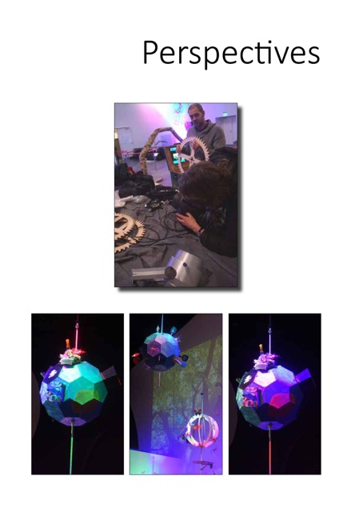

Perspectives
PhD Anne Kirketerp points out that the resent years have introduced the municipal primary and lower secondary schools to a comprehensive demand towards documenting the students' reading and mathematical skill through test scores.

She argues that this creates a race, among the students, towards receiving high grades and being the best in the class. Furthermore, the focus on the right result and a test score can in some circumstances create “learned helplessness” (Kirketerp & Svennevig, 2016, p 39). She views this tendency as a prevention towards building an innovative culture.
Rane Willerslev, professor in social anthropology at the university of AArhus, in the newspaper article “Denmark needs others then the A+ girls and boys – the correctness culture deflates an entire generation of scientists” supports Anne Kirketerp’s concerns. The following paragraph is translated from the newspaper article:
“Everybody points to the fact that Denmark must be an innovation society, and that we can only succeed in the global competition if we can get new ideas and generate creative solutions. I agree. The question is whether the education system we have created, with more and more tests and focus on accuracy, is leading to more innovation. I do not think it does. On the contrary! Such is the analysis of 44-year-old Rane. He fails the entire Danish education system - from the first form at the primary school to the last semester at the university - for having stared blindly at indifferent skills, correct responses and high grades. The grade A+ is given to the 100 percent correct answers, we reward those who are good at giving correct answers - while the ones trying radical and wild thoughts are punished with low grades. But world-class science includes taking risks and it requires a culture that accepts an error and room to misstep”. (Willerslev, 2015)
I personally believe that innovation, the open school agenda and projects like ClimateZircus and Jet-Net can, to some extend, meet the concerns that Anne Kirketerp and Rane Willerslev express. Although, it demands development and implementation of new didactics that supply the teachers with a better understanding of how innovation processes are successfully applied in the primary and lower secondary school system.

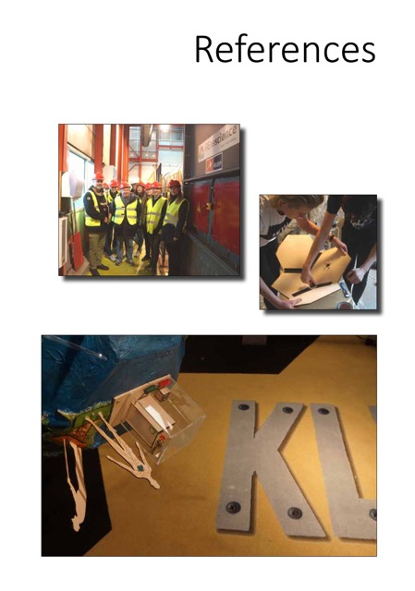

References
Adriansen, H.K and Madsen, Lene Møller (2009): Studying the making of geographical knowledge: The implications of insider interviews, Norsk geografisk tidsskrift – Norwegian Journal of Geography, 63:3,145-153

Adriansen, H.K. (2012): “Timeline interviews: a tool for conducting life history research.”

Amabile, T.M. Hadley, K. & Kramer, S.J. (2002): “Creativity under the gun”, Harvard Business Review

Amabile, T, (1998): ”How to Kill Creativity”, Harvard Business Review (The September – October issue)

Cross, R., Parker, A. (2004): ”The hiddenpower of social networks”,Harvard Business School Press
Ananiadou, K. & M. Claro (2009)” 21st Century Skills and Competences for New Millennium Learners in OECD Countries, OECD Education Working Papers, No. 41, OECD Publishing

Danish Ministry of Education (2010): Welcome to the Danish Folkeskole”, The Ministry of Education, Copenhagen.

Danish Ministry of Education (2014): “Improving the Public School – overview of reform of standards in the Danish public school (primary and lower secondary education)”, The Danish Ministry of Education

Darsø, Lotte (2001): Innovation in the making, Samfunds litteratur

Darsø, Lotte (2007): ”Is there a formula for innovation?”, translated from the article by Lotte Darsø (2003): ”En formel for innovation”, Børsen Ledelseshåndbøge

Darsø, Lotte (2011):”Innovationspædagogik”, samfunds litteratur

Darsø, Lotte (2014): Slides from LAICS module 1 seminar 1.

Deloitte, Engeneer the future (2016): “Skole-virsomhedssamarbejde – en del af løsningen”

Dewey, J. (1913): Interest and effort in education. Boston, MA: Riverside.

Furman, Jeffrey L., Michael E. Porter, and Scott Stern. "The Determinants of National Innovative Capacity." Research Policy 31, no. 6 (August 2002): 899–933.

Garud, R., Tuertscher, P., & Van de Ven, A. H. (2013). Perspectives on Innovation Processes. The Academy of Management Annals, 7(1), 775–819. doi:10.1080/19416520.2013.791066

Government agreement, the Social Democrats, the Social- Liberal Party, the Socialist People’s Party, the Liberal Party of Denmark and the Danish People’s Party (2013): ”Improvement of standards in the Danish public school – primary and lower secondary education”, www.eng.uvm.dk

Government agreement (2012): Danmark, Løsningernes land, Ministeriet for forskning, innovation og videregående uddannelser.

Høyrup, S. (2012): ”Employee-Driven Innovation: A new Approach”, Palgrave Macmillan
Hidi, S. (2006): Interest: A motivational variable with a difference. Educational Research Review, 7, 323–350

Jensen, A (2011): “Science municipalities - education for growth,
www.formidling.dk/science-municipalities

Jerlang, Espen (2006): udviklings teorier – en introduktion, Hans Reitzel

Kvale, Steinar (1996): “Interviews An Introduction to Qualitative Research Interviewing”, Sage Publications

Kirketerp, Anne, & Svennevig Hyldig (2016): “Innovation I folkeskolen”, Dansk Psykologisk forlag A/S.

Nielsen, Jan Alexis (2015) “Evaluering af Gymnasiet tænkt forfra”( translated to – ”The Upper Secondary School thoughtover agian”), institut for naturfagenes didaktik, University of Copenhagen.

Nissen, P. (2011). “Theory- and evidence-based intervention: Practice-based evidence – Integrating positive psychology into a clinical psychological assessment and intervention model and how to measure outcome”, Psychology Research, 1(2), 91-105

Nissen, P. (2012): “Hvordan måler man om eleverne lærer noget i skolen”, Økonomi & Politik nr. 2-2012 – s. 25

Markides, C., & Geroski, P. (2005). Fast second: How smart companies bypass radical innovation to enter and dominate new markets (1st ed.). San Francisco: Jossey-Bass.

McLean, (2005): Organizational Culture´s Influence on Creativity and Innovation: A Review of the Literature and Implications for Human Resource Development, Advances in Developing Human Resource
Moberg, Kåre (2014): ”Two approaches to entrepreneurship education: The different effects of education for and through entrepreneurship at the lower secondary level”,
The International Journal of Management Education, Volume 12, Issue 3, Pages 512–528

Per-Erik Ellström, (2010),"Practice-based innovation: a learning perspective", Journal of Workplace Learning, Vol. 22 Iss 1/2 pp. 27 - 40

Petersen, Morten Rask, (2012): Interesseudvikling i naturfagene gennemfaglig progression, Center for Naturvidenskabernes og Matematikkens didaktik

Qvist-Sørensen, Ole (2015): Workshop in graphic facilitation, LAICS seminar 3 module 3.
Ryan, R.M. & Deci, E.L. (2000): Intrinsic and extrinsic motivations: classic definitions and new
directions. Contemporary Educational Psychology 25, 54-67.

Sfard, Anna (1998): On Two Metaphors for Learning and the Danger of Choosing Just One, Educational Researcher, Vol 27, 2, pp 4-13.

Stacey, Ralph D. (1996): “Complexity and Creativity in Organization’s” Berrett-Koehler Publishers, San Francisco

Stake, RE. (1994): Case Studies. In NK Denzin & YS Lincoln (Eds.) Handbook of Qualitative Research (pp. 236-247). Thousand Oaks, Sage Publications.

Sølberg, J., Holst Waaddegaard, N., Hansen, F. L., Trolle, O., Elmeskov, D. C., Johannsen, B. F., & Nielsen, J. A. (2015). Innovation, Science og Inklusion 2015: Slutrapport af ISI 2015. Dansk Naturvidenskabsformidling.

Todt, E. (1978):. Das Interesse – Empirische Untersuchungen zu einem Motivationskonzept, Hans Huber.

Wilber, Ken (2000), A Brief History of Everything, Shambhala Publications

Willerslev, Rane (2015): “Danmark har ikke kun brug for 12-tals piger og drenge - Korrekthedskulturen afliver en hel generation af topforskere.”, Politiken, 29’th of august.

Yin, Robert K. (1994): Case Study Research. Design and methods, Applied Social Research Methods Series, Volume 5, Sage Publication.

Webapges:
www.designtoimprovelifeeducation.dk
www.edglossary.org
www.emu.dk
https://www.youtube.com/watch?feature=player_embedded&v=QbTvEaTmXA
o#at=251
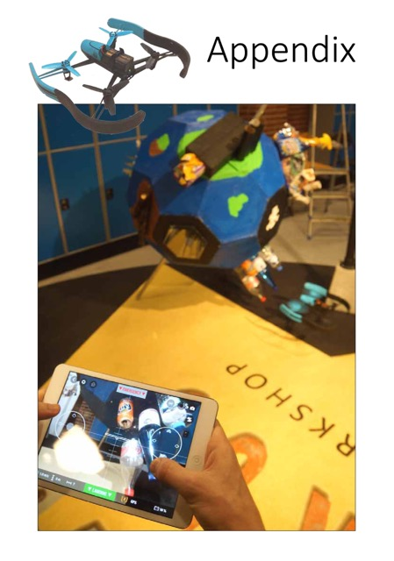

Appendix

Appendix 1 – The Digital Logbooks
http://rasmusemmacamillaogarsim.tumblr.com/
http://unknown-kjaj.tumblr.com/
http://gruppefrum.tumblr.com/
http://angryperfectioncowboy.tumblr.com/
http://badqueenposts.tumblr.com/
http://championsofdansborg.tumblr.com/
http://lortegruppen.tumblr.com/
http://desejesamc.tumblr.com/
http://viktorkasperalexsimon.tumblr.com/
http://patrickhabibmichaelsaad.tumblr.com/
http://thegoldentrash.tumblr.com/

Appendix 2 - Focus group interviews, the students, day one
Focus group interview, day one, students | Main topics | Example of interview text
Step 1  I listen to the full interview and write down the main topics | Expectations towards the innovations process  Expectations towards working with a real life challenge and business | Expectations towards the innovations process  innovation processes are new to us  and we need to think I a different way  the Compass can give us tool to help with a structure.  interesting that we can’t read the answer in a book.  Expectations towards working with a real life challenge and business.  it is motivating to meet the “real world”  nice that we get to work with experts  we will learn things needed in the real world.  motivating to see the “inside” of a company.  a nice break from the “normal” school
Step 2  I listen to the full interview and pays attention to certain topics | Expectations towards the innovations process | we need to be able to work together, use logic and listen to other.  I think that a lot more students will be able to contribute… Normal assignments focus on an academic content like spelling and calculating, but I think innovation open up for different competences.
Step 3  I listen to the full interview and pays attention to certain topics | Expectations towards working with a real life challenge and business | we will learn something we can’t learn from the teachers  we need to know what we present and how to communicate in the end of project, because the companies are experts know what we talking about.  - that it will be relevant, interesting and currently.  - that it is more “real”  - it is interesting that we can, maybe, solve problems and help the local community. It makes me feel a greater ownership to my project.  - that we need to know what we present in the end of project, because the companies are experts know what we talking about  - cool that the learning is generate outside the classroom.
Focus group interviews, the students, day one

Appendix 3 - Focus group interviews, students, day five
Focus Group interview, day five, students | Main topics | Example of interview text
Step 1  I listen to the full interview and write down the main topics | Innovation and the tools, assignment used in the innovation process  Visual facilitation and the “project wall” | Innovation and the tools, assignment used in the innovation process.  The Compass and the assignment is a good tool, but it is frustrating that we haven’t started to produce a product.  difficult because we have not used an innovation process before.  Visual facilitation and “the project wall”.  “The project wall” helps us to get on the same page.  I like that is give us visual pictures of our process.
Step 2  I listen to the full interview and pays attention to certain topics | Innovation and the tools, assignments used in the innovation process. | we are learning to network and share ideas.  the assignments give us new ideas and perspectives.  Innovation allows us to use the different competences of people in the group.  the innovation process and assignments gives with a structure that helps us to communicate and work as a team.
Step 3  I listen to the full interview and pays attention to certain topics | Visual facilitation and the project wall. | “The project wall” is where we have our common thoughts  “The project wall” helps us to get the full picture of our process.  we use “The project wall” to post our assignments and ideas.
Focus group interviews, students, day five

Appendix 4 - Questionnaire, the students, day ten
Main topics | Example of interview text – the number indicate amount of statement with a similar topic.
How has the innovation process affected your work ethic? | It was frustration at first, but it had a positive effect at the end (5)  It had positive effect (7)  It made me think outside the box and open be open to new ideas (9)  It helped me to collaborate with my team (2)  Increased my sense of ownership and help to be self-employed (6)
What have you learned from the innovation process? | to generate new ideas (15)  to master the innovation process and tools (8)  to be open to new ideas and different viewpoints (4)  to be self-employed (2)  to collaborate in a team and to compromise (5)  to dwell on an assignment and have patience with the process (2)  don’t know (3)
What have you learned from co-creating with a local business | academics (10)  to collaborate (4)  to be self-employed and responsible (1)  how to contact a business and the “outside world” (7)  don’t know (2)  to deal with the “real work life” and my ideas can come to life (9)
How did “the project wall” affect the team? | It gave us a better overview of the process (18)  It gave us a common understanding (8)  It created a better focus (9)  It helped to create ideas (2)  we were afraid it was ugly (1)  It didn’t have an effect. (7)
What has been difficult? | to collaborate and compromise (17)  to build a product and using tools(4)  to get the right idea (4)  to generate data on and involve the users (2)  time pressure (3)  understanding the innovation process (5)
What has been the most important competence in the innovation process? | to collaborate (11)  Understanding of and using The Compass (4)  to visualize your thoughts (2)  self-employment (2)  to think outside the box (2)  to construct and build a product (1)  academics (1)
Figure 1 – questionnaire, the students, day ten

Appendix 5 - Focus group interview, the teachers, day one
Focus Group interview day one - Teachers | Main topics | Example of interview text
Step 1  I listen to the full interview and write down the main topics | How does it make sense to work with innovation in the school system?  What expectations  do you have on the academic level?  What thoughts do have concerning co-creating with a local business?  What thoughts do have concerning that the students are co-creating with a “real challenge” | How does it make sense to work with innovation in the school system?  We teach the students how to focus on a process, and I can as a teacher guide them through the process.  What expectations do you have on the academic level?  The students choose the academically tools and subjects they want to use and we focus on 21. Century skills.  What thoughts do have concerning co-creating with a local business?  By meeting an “expert” - We expect that the students will take ownership to the project.  What thoughts do have concerning that the students are working with a “real  We expect that the students will find it liberating and motivating that  We have constructed the problem statements s real life challenge.
Step 2  I listen to the full interview and pays attention to certain topics | How does it make sense to work with innovation in the school system?  What expectations do you have on the academic level? | How does it make sense to work with innovation in the school system?  When we do bigger projects  the students learn to communicate  21. Century skills  it will help the students to stay in a work process  the process invites the academics “weak” to use their competences.  the students learn to contact the “real world”  the student is given tools to collaborate in teams  we expect that it will be a challenge to keep to students from wanting to create a solution on day one.  I see a possibility of integrating the different innovation assignment into the “normal” lessons. (in the future)  The students need to transfer the knowledge from the books to a producing a product. This is done in collaboration with a company which means the students knowledge is related to the real world and is use to create value for other.  What expectations do you have on the academic level?  I expect that I will have to let go on the academics, but that the students learn project process.  I expect that the students will choose what academics they want to bring in to the project.  I do not have any expectations towards any specific academic goals.
Step 3  I listen to the full interview and pays attention to certain topics | What thoughts do have concerning co-creating with a local business?  What thoughts do have concerning that the students are working with a “real challenge” | What thoughts do have concerning co-creating with a local business?  it demands a greater amount of planning, and we use a person from the municipality to contact the local business - we can’t do it without her.  we expect that it will give the project an aspect of being more real and that this will spark the student’s interests and motivation.  we hope the students will get a better understanding of the “real work life”.  What thoughts do have concerning that the students are working with a “real challenge”  it is difficult for the students to write a problem statement and by handing them a real challenge will probably release energy.  I expect that it will motivate at spark an interest.  the students will enjoy that they can learn other places than in a classroom.
Focus group interview, the teachers, day one
Appendix 6 - Focus group interview, the teachers, day five
Focus group interview, day six,  Teachers | Main topics | Example of interview text
Step 1  I listen to the full interview and write down the main topics | The process and tools  The teacher’s role  Advice to others | The process and tools  some students are frustrated because they lack understanding of the process, but they enjoy working with the assignments  The teacher’s role  I have become a teacher with focus and facilitating the students’ own innovation and learning process.  Advice to others  We have several advices that other could benefit from.
Step 2  I listen to the full interview and pays attention to certain topics | The process and tools | The process and tools  the students want to create a solution, but we try to keep them to stay in the first two phases of the compass - the prepare- and perceive phase. This is frustrating to some of groups.  the students have started to contact people outside the school. They understand that they can get information from other sources then the library and google – this I a good thing.  the students use a lot of time on the collaboration in the team, and it seems as innovation tools like “De Bonos thiking hats” and the visual aspect helps the teams commnunicate.
Step 3  I listen to the full interview and pays attention to certain topics | The teachers’ role  Advice to others | The teachers’ role  I now have patent on the process but have let go on the product. I give the student a big freedom and responsibility. Some grow with this experience and other need a hand, but the guidelines of the Compass helps the “theoretical weaker” students to get through the project.  I want the students to learn the innovation process and assignment. It does not matter have respectable the final product is.  Advice to others  it is important to have coordinator who handles the contact with the local business. It takes a lot of time and the team of teacher needs help to handle this task.  it is important that the team of teachers reserve time for common reflection with the coordinator.  use the innovation assignment in the normal lessons. This will preclude the student’s frustrations and enable the students to understand the innovation process better.
Focus group interview, the teacher, day six

Appendix 7 - Questionnaires, the teachers, day 10
Main topics | Example of interview text
How has The Compass affected the students work? | it has been a positive tool  it gave the student’s a good work structure  it helped the student to produce a product that has been thought trough
What has the students learned from working with The Compass | it thought the students a process  different assignments to control an innovation process  tools to increase collaboration and communisation in a team.  generate data through interviews  generate data with other methods then using Google
What has co-creation with a local business learned the students? | That they have the competences to solve a challenge origin from the “real life”. This gives the students an amount of pride and confidence.  To conduct a prober interview  Generate and handling data  The experts have given the students a vast amount academic knowledge  The students are happy to present their work to the companies.
How has “the project wall” affected the team’s collaboration? | It has help the students to have an overview of the process.  It has provided some calmness in project full of ”chaos”.  Help them to structure the work load.  Help them to explain and develop ideas.
What has been difficult? | the first week was frustrating (both for teachers and students)  it has been difficult to explain the process to the students (the first week)  it is difficult to find a balance between the importance of final product and the process.  working with local businesses demand lots of planning.
What has been the most important competence in the innovation process? | The ability to generate prober data and handle the data in a constructive manner.  To collaborate with your own team and the other teams  To collaborate with a business and prepare for the collaboration with the expert  To have the courage to do something unexpected  To generate ideas and select the right ideas  To have patience to go through the entire innovation process before you develop your product
Has the student used academic skills and how? | Use of Exel and other computer programs  They used academics to analyze data, ideas and research.
Do the students learn the same things as in “a normal” school project? | No, the get to use all of their competences in an authentic context.  They are more process oriented and we have experienced that the weak students tend to get better grade. We think it relates to the fact that they can draw on the team’s strengths. The freedom to make your own choice and vast time to reflect on your work does also help.  The students need to transfer the knowledge from the books to a producing a product. This is done in collaboration with a company which means the students’ knowledge is related to the real world and is use to create value for other.
Questionnaire, the teachers, day 10

Translated by me; the original name is: ”Danmark – løsningernes land”
Translated by me; the original name is: “KlimaZirkus – Building Workshop”
Translated by me; the original name is: ”Gymnasiet tænkt forfra”
Translated by me; the original name is: ”Elever af Ellehammer”
Project report: http://media.wix.com/ugd/f4c41d_bf0acdf993c046888f23dffb270201a0.pdf
translated by me from the Danish word “læringsrum”
The number in the parenthesis indicates how many times a student gave a similar answer:
Original title “Skole-virksomhedsamarbejde – en del af løsnignen” – The title is translated by me.
The terms refer to The Time-Pressure/Creativity Matrix (Amabile Hadley, K. & Kramer, S.J., 2002)
Translated by me. The original titel is “Undervisning i undervisningen”.
Translated by me. The original titel is ”Den visulle lærer” - http://www.toolsforschools.dk/den-visuelle-laeligrer.html
Translated by me - origional title is: ”Danmark har ikke kun brug for 12-tals piger og drenge - Korrekthedskulturen afliver en hel generation af topforskere.”

